Business Requirements Document (BRD)

Marriage Registration Module
Field | Value
Document ID | BRD-K3-MRG-001
Version | 4
Status | Final — workshop additions: SMA Sec. 15/16 residence gate; notification cross-links; certified-copy cross-refs; e-Gov address; certificate language preview; Form II removed; e-Janma/Marks Card; SR Refusal order
Module | Marriage Registration
Legal basis (primary) | The Hindu Marriage Act, 1955; The Special Marriage Act, 1954; The Parsi Marriage and Divorce Act, 1936
State rules (primary) | Registration of Hindu Marriage (Karnataka) Rules, 1966; Special Marriage (Karnataka) Rules, 1961
Author (BA) | Nandha Kumar
Product Owner | M V Prashanth
Domain expert / SRO reviewer | Prabhakar Naik, Committee members
Target audience | Kaveri IT Cell, Department of Stamps and Registration, Government of Karnataka
Last updated | 09-09-2026

Document control
Version | Date | Author | Summary of change | Approver
1 | 27-08-2026 | Nandha Kumar | Initial BRD | Prashanth
2 | 03-09-2026 | Nandha Kumar | Review Committee suggestions:  - Updated Aadhaar OTP message to include a valid reason  - Updated process flow messages for notice filing  - Added age validation at the time of notice filing  - Added Form II for Hindu Marriage  - Added new sections on applicable Acts, Rules, and sections  - Split the document into separate BRD and FRS–NFR documents  - Added references in the pain-points section | Prashanth
3 | 04-09-2026 | Nandha Kumar | Added Parsi Marriage: new BRD requirements and 7.iv process diagrams (Online / Offline); Section 3 updated with the Parsi Marriage and Divorce Act, 1936, the Parsi Marriages and Divorce (Karnataka) Rules, 1961, Notification HD 6 PIM 67 and the Schedule II certificate form mapping; updated 7.vi What is new in Kaveri 3.0 | Prashanth
4 | 09-09-2026 | Nandha Kumar | SMA Sec. 15/16: residence ≥ 30 days before notice application; cross-link 3.4 notifications into related Acts/sections/rules; multiple cross-references on certified copy; e-Governance address standard; certificate language selection + preview; remove Form II for Hindu Marriage; e-Janma / Marks Card birth-certificate pull; SR Refusal with reason and order before registration/solemnization | Prashanth

Contents
Marriage Registration Module 1
Document control 1
1. Executive summary 5
2. Scope 5
3. Legal and regulatory reference 6
i. Applicable Acts 6
ii. Relevant sections followed by the Department for Marriage Registration 6
iii. Relevant rules followed by the Department for Marriage Registration 10
iv. Relevant notifications issued by the Department for Marriage Registration 13
v. Hindu Marriage statutory forms mapping 15
vi. Special Marriage statutory forms mapping 20
vii. Parsi Marriage statutory forms mapping 24
viii. Sakala — Karnataka Guarantee of Services 25
4. Stakeholders and actors 26
5. Definitions and glossary 27
6. Current state 28
i. As-Is pain points 28
7. Future state (To-Be) 33
i. Hindu Marriage 33
ii. Special Marriage Notice Generation (Intended Marriage / Other Forms) 38
iii. Special Marriage Marriage Registration (Intended Marriage / Other Forms) 44
iv. Parsi Marriage 48
v. Marriage — Null and Void Endorsement (Court Order) 54
vi. What is new in Kaveri 3.0 55
8. Functional requirements 58
i. Hindu Marriage 58
ii. Special Marriage (Intended Marriage/Other Forms) Notice Generation 71
iii. Special Marriage (Intended Marriage/Other Forms) Marriage Registration 81
iv. Parsi Marriage 86
v. Post-registration services 95
vi. Notifications 98
vii. Reports and MIS 99
viii. Sakala integration (Karnataka Guarantee of Services) 101
ix. Scanning Module (shared platform) 103
x. Business rules 104
xi. User interface (high-level) 110
xii. Integrations 114
xiii. Data requirements 116
xiv. Requirements traceability matrix (RTM) - template 117
9. Non-functional requirements 119
i. Performance and Scalability 119
ii. 8.2 Security and Data Privacy 120
iii. 8.3 System Availability and Error Handling 121
iv. 8.4 Security Audit and Compliance (VAPT Policy) 121
10. Risk and Mitigation Strategy 122
11. System Fallbacks & Error Handling 123
12. Training and Change Management 126
i. Target audience 126
ii. Training delivery 126
iii. Citizen change management 126
iv. Post-Go-Live support 126
13. Appendix A — References 126
14. Acceptance and sign-off of BRD 127

Executive summary
This document presents a comprehensive assessment of the existing Hindu Marriage Registration process, Special Marriage (Intended Marriage / Other Forms) notice and registration processes, and Parsi Marriage registration, covering both online and offline service channels. It identifies key operational, procedural, and user experience challenges currently impacting applicants and Sub-Registrar offices.
Based on the analysis of the current state, the document proposes an enhanced future-state workflow aimed at improving accessibility, efficiency, transparency and service delivery. In addition, it defines the functional and non-functional requirements, outlines the data requirements required for effective implementation and management, and provides a reference to a detailed traceability matrix to ensure alignment between business objectives, requirements and solution deliverables.
The proposed approach is intended to streamline marriage registration services, reduce manual effort, enhance compliance, and establish a scalable foundation for future digital transformation initiatives.

Scope
- Hindu Marriage registration — Online and Offline channels.
- Special Marriage — Intended Marriage: notice generation (Online & Offline), objection period, solemnization and registration.
- Special Marriage — Other Forms: notice generation (Online & Offline), objection handling and registration.
- Parsi Marriage registration — Online and Offline channels.
- Citizen portal and SRO desk workflows: apply, pay fee, scrutiny, approve/reject, register, and issue certificate.
- Null and Void endorsement of a registered marriage on court order.
- Integrations: payment, Aadhaar/e-KYC, DigiLocker, SMS, e-Mail, Kutumba, Civil Registration System, Labor Department, and Sakala.
- Bilingual UI (English + Kannada); audit trail, role-based access, and MIS/reporting.

Legal and regulatory reference

Applicable Acts
The Department for Marriage Registration (through Sub-Registrars / Marriage Officers) administers the following Central Acts and Karnataka Rules:
Act | Description
The Hindu Marriage Act, 1955 | Registration of Hindu marriages (Sec. 8); conditions for marriage (Sec. 5); ceremonies (Sec. 7); Notifications: S.O. 4896 / HD 6 CIM 61 (4 Jul 1966); Registration of Hindu Marriages (Karnataka) (Amendment) Rules, 1999; G.S.R. 314 / G.S.R. 394 / HD 5 PIM 69; RD/48/MNMU/2023 (Amendment Rules, 2024); koE/65/mnmu/2021 (age proof); MME 109 MABHAB 2017 (address proof) — see §3.4
The Special Marriage Act, 1954 | Solemnization of special marriages (Chapter II); registration of marriages celebrated in other forms (Chapter III); Notifications: Special Marriage (Karnataka) Rules, 1961 (Notification No. HD 13MCIM 59(1), 2 May 1961); koE/65/mnmu/2021 (age proof); MME 109 MABHAB 2017 (address proof) — see §3.4
The Parsi Marriage and Divorce Act, 1936 | Marriage between Parsis solemnized per Parsi rites — the ‘Ashirvad’ ceremony (Sec. 3); certificate and registry of marriage by the Registrar (Sec. 6); appointment of Registrar (Sec. 7); register open for public inspection (Sec. 8); Notifications: Notification No. HD 6 PIM 67 (1967); Parsi Marriages and Divorce (Karnataka) Rules, 1961 (Notification No. HD 13 CIM 59) — see §3.4
The Karnataka Guarantee of Services to Citizens Act, 2011 | Time-bound guarantee of citizen-related services; GSC acknowledgement; online status monitoring; appeals and compensatory cost (Secs. 3–13); amended by Karnataka Act 36 of 2012 and Karnataka Act 31 of 2014; Notification / rules: Karnataka Guarantee of Services to Citizens Rules, 2012 (Gazette 29-Feb-2012) — see §3.4

Relevant sections followed by the Department for Marriage Registration

Hindu Marriage Act, 1955 (selected sections for registration)

Section | Topic | relevance | Refer section 7 for Implementation
Sec. 2 | Application of Act | Eligibility — Hindus (incl. Virashaiva, Lingayat, Brahmo/Prarthana/Arya Samaj), Buddhists, Jainas, Sikhs; | 7.i.b.A (service selection / Hindu marriage eligibility)
Sec. 3 | Definitions | Sapinda relationship and degrees of prohibited relationship — validation rules | 7.i.b.A (sapinda and prohibited-relationship capture)
Sec. 5 | Conditions for a Hindu marriage | Age (bridegroom ≥ 21, bride ≥ 18); no living spouse; consent; prohibited degrees / sapinda unless custom permits — Form IA declarations; Age proof per circular koE/65/mnmu/2021 (Birth certificate / School Certificate / medical certificate; Aadhaar not age proof) — §3.4 | 7.i.b.A (prerequisite, declarations and Form IA)
Sec. 7 | Ceremonies for a Hindu marriage | Customary rites and ceremonies; Saptapadi — solemnization evidence | 7.i.b.A (marriage details / ceremony evidence)
Sec. 8 | Registration of Hindu marriages | State rules power; register open for inspection; certified extracts; validity of marriage not affected by omission to register; S.O. 4896 (Sub-Registrars as Registrars); RD/48/MNMU/2023 electronic filing / register / certificate; Amendment Rules 1999 (Form IA, II-A, scrutiny/refusal) — §3.4 | 7.i.b.B, 7.i.b.C, 7.i.b.D (registration process and status)
Sec. 11–12 | Void / voidable marriages | Court nullity endorsement — SRO flags registered marriage Null and Void on receipt of court order (Sec. 11 void; Sec. 12 voidable / annulled) | 7.v (court-order null/void endorsement)
Sec. 17 | Punishment of bigamy | Messaging linked to Sec. 5(i) declaration | 7.i.b.A (no living spouse declaration messaging)
Sec. 18 | Punishment for other Sec. 5 breaches | Citizen / SRO awareness — not automated prosecution | — (citizen / SRO awareness only)

Special Marriage Act, 1954 (selected sections)

Section | Topic | BRD relevance | Implemented in (7)
Sec. 4 | Conditions relating to solemnization | Eligibility / prerequisite checks before notice; Age / eligibility evidence per koE/65/mnmu/2021 — §3.4 | 7.ii.b.A, 7.iii.b.A (solemnization eligibility checks)
Sec. 5 | Notice of intended marriage (Second Schedule) | Generate and capture notice; jurisdiction — ≥ 30 days residence of at least one party before the date of notice application; Address proof documents per MME 109 MABHAB 2017 — §3.4 | 7.ii.b.A–7.ii.b.D (notice generation and capture)
Sec. 6 | Marriage Notice Book and publication | Enter notice; publish on portal and/or notice board; transmit if party resides elsewhere | 7.ii.b.B, 7.ii.b.C (Marriage Notice Book and publication)
Sec. 7 | Objection to marriage (30 days) | 30-day countdown from publication; accept and record objections | 7.ii.b.D, 7.iii.b.C (30-day objection window)
Sec. 8–9 | Procedure / enquiry on objection | SR enquiry; summon parties; uphold or reject objection | 7.ii.b.D, 7.iii.b.C (objection enquiry workflow)
Sec. 11 | Declaration by parties and witnesses (Third Schedule) | Declarations before solemnization; three witnesses | 7.iii.b.A–7.iii.b.B (Third Schedule declarations)
Sec. 12–13 | Solemnization and certificate of marriage (Fourth Schedule) | Office solemnization; certificate issuance | 7.iii.b.B (solemnization and Fourth Schedule certificate)
Sec. 14 | New notice if not solemnized within three months | Block registration outside validity; require fresh notice | 7.iii.b.C (notice validity / fresh-notice gate)
Sec. 15 | Registration of marriages celebrated in other forms | Other Forms eligibility — ceremony performed; parties living together; ages; residence ≥ 30 days before the date of notice application; Age proof per koE/65/mnmu/2021; address proof per MME 109 MABHAB 2017 — §3.4 | 7.ii.b.A, 7.iii.b.A (Other Forms eligibility)
Sec. 16 | Procedure for registration — Other Forms (Fifth Schedule) | Public notice; 30-day objections; certificate with three witnesses; Sec. 15 conditions (incl. residence ≥ 30 days before the date of notice application) apply before registration; Procedure under Special Marriage (Karnataka) Rules, 1961 (Notification No. HD 13MCIM 59(1)) — §3.4 | 7.ii.b.x, 7.iii.b.x (Other Forms notice and registration)
Sec. 47–48 | Marriage Certificate Book; transmission to Registrar-General | Inspection; certified extracts; quarterly transmission | 7.iii.b.B, 7.iii.b.C (register entry; extracts — partial back-office)

Parsi Marriage and Divorce Act, 1936 (selected sections for registration)
Section | Topic | relevance | Refer section 7 for Implementation
Sec. 3 | Requisites to validity of Parsi marriages | Prohibited degrees of consanguinity / affinity (Schedule I); solemnization per the Parsi form of ceremony (‘Ashirvad’) by a priest before two Parsi witnesses; age (bridegroom ≥ 21, bride ≥ 18) | 7.iv.b.A (prerequisite, declaration and eligibility capture)
Sec. 4 | Remarriage when unlawful | No remarriage during the lifetime of a spouse without lawful divorce, annulment or dissolution | 7.iv.b.A (no living spouse declaration messaging)
Sec. 6 | Certificate and registry of marriage | Officiating priest certifies the marriage in the Schedule II form immediately on solemnization, signed by the priest, both parties and two witnesses; sent with fee to the Registrar of the place of solemnization; Registrar enters the certificate in the marriage register | 7.iv.b.B, 7.iv.b.C (Schedule II certificate capture and register entry)
Sec. 7 | Appointment of Registrar | Registrar appointed by the Chief Justice (within a High Court’s original civil jurisdiction) or by the State Government (elsewhere); Notification No. HD 6 PIM 67 — Sub-Registrars as Registrars — §3.4 | 7.iv.b.B, 7.iv.b.C (Sub-Registrar as Registrar routing)
Sec. 8 | Marriage register open for public inspection | Register open at all reasonable times; certified extracts on payment of fee; register is evidence of the statements it contains | 7.iv.b.B, 7.iv.b.D (register inspection and certified extracts)
Sec. 9 | Copy of certificate sent to Registrar-General | Registrar sends certified copies of register entries to the Registrar-General of Births, Deaths and Marriages at prescribed intervals | — (periodic back-office transmission)
Sec. 10 | Registration of divorces | Court sends a divorce / nullity / dissolution decree to the Registrar for entry in a separate register | 7.v (court-order null / void endorsement)
Sec. 12–16 | Penalties — priest’s neglect, omission to subscribe/attest, false certificate, failing to register, secreting / destroying register | Citizen / Registrar awareness — not automated prosecution | — (citizen / SR awareness only)
Sec. 17 | Formal irregularity not to invalidate marriage | A defective, irregular or unsent certificate does not invalidate the marriage | — (validation messaging only)

Relevant rules followed by the Department for Marriage Registration
Karnataka subordinate legislation made under the Hindu Marriage Act, 1955 (Sec. 8), the Special Marriage Act, 1954 (Sec. 50) and the Parsi Marriage and Divorce Act, 1936 (Sec. 9).

Registration of Hindu Marriage (Karnataka) Rules, 1966
Rule | Requirement | Refer section 7 for Implementation
Rule 2 | Definitions — Act, form, Marriage, Memorandum, Priest, Register, Registrar, Registrar-General, witness | 7.i.b.A (glossary-driven eligibility validation)
Rule 3(1) + S.O. 4896 | Appointment of Registrars; all Sub-Registrars under Registration Act 1908 appointed Registrars for their jurisdictions (HD 6 CIM 61, 4 Jul 1966); Instrument: S.O. 4896 / HD 6 CIM 61 (4 Jul 1966) — §3.4 | 7.i.b.B step 8, 7.i.b.C (SRO office / jurisdiction routing)
Rule 4(1) | Parties prepare and sign Form I in duplicate; deliver in person, registered post or electronically; jurisdiction = marriage place or ordinary residence of bridegroom/bride; G.S.R. 314 / G.S.R. 394 / HD 5 PIM 69; RD/48/MNMU/2023 ('or electronically') — §3.4 | 7.i.b.B, 7.i.b.C (Online / Offline filing and office selection)
Rule 4(2) | Memorandum delivered with application in Form IA; Amendment Rules, 1999 (Form IA) — §3.4 | 7.i.b.A–7.i.b.C (Form IA linked to memorandum)
Rule 4(3) | Memorandum and duplicate signed by three witnesses | 7.i.b.A, 7.i.b.C (three witnesses; eSign / physical signature)
Rule 4(4) | Endorsement in Form II; paste in paste-book register or stored electronically; RD/48/MNMU/2023 ('or stored electronically'); Kaveri 3.0 does not require a separate Form II artefact — electronic register endorsement on Form II-A issuance — §3.4 / §3.5 | 7.i.b.B, 7.i.b.C (electronic register endorsement / Form II-A)
Rule 4(5) | On completion of registration, immediately issue Form II-A certificate; Amendment Rules, 1999 (immediate Form II-A); RD/48/MNMU/2023 — §3.4 | 7.i.b.B, 7.i.b.C (Form II-A certificate issuance)
Rule 5 | Monthly duplicate memoranda to Registrar-General with Form III certificate | — (monthly Form III batch — 8.vii / back-office)
Rule 6 | Indices Forms IV and V at every Registrar | — (Forms IV & V indexes — 8.vii MIS / search)
Rule 6A | Power to require duplicate / Form IA / remedy defects; forward if outside jurisdiction; scrutinise and refuse with brief written order; Amendment Rules, 1999 (scrutiny / written refusal order) — §3.4 | 7.i.b.B, 7.i.b.C (defect remedy, forward, written refusal)
Rule 8 + Schedule | Certified extracts on application + fee; search fee provisions | 7.i.b.B, 7.i.b.C (payment and certified-extract fees)
Rule 9 | Receipt in Form VI for every fee; credit to State Government | 7.i.b.B, 7.i.b.C (Form VI payment receipt)
Rule 10 | Custody and preservation of registers and records | — (records retention — NFR / archival policy)

Special Marriage (Karnataka) Rules, 1961

Rule | Requirement | Implemented in (7)
Rule 3 | Marriage Officer shall display name, designation and working hours in English and Kannada | 7.ii.b.A (Marriage Officer office master / display)
Rule 4 | Notice in Second Schedule form; in person or registered post; fee on delivery; serial number and Marriage Notice Book entry; exhibition of true copy; Made under Notification No. HD 13MCIM 59(1), 2 May 1961 — §3.4 | 7.ii.b.A–7.ii.b.D (Second Schedule notice generation)
Rule 6 | Objection enquiry — recording, summons (Forms I & II), 30-day enquiry window, decision in writing | 7.ii.b.D, 7.iii.b.C (objection enquiry and decision)
Rule 7 | Application for registration of marriage in other forms (Form III); public notice exhibition; 30-day objection period; Notification No. HD 13MCIM 59(1); Other Forms path — §3.4 | 7.ii.b.x, 7.iii.b.x (Other Forms Form III notice path)
Rule 8 | Solemnization outside office on application + additional fee | 7.iii.b.B (optional out-of-office solemnization fee)
Rule 9 | Marriage Certificate Book — bound volume, consecutive numbering, index | 7.iii.b.B (Marriage Certificate Book / numbering)
Rule 10 | Fee schedule — notice fee, registration fee, objection fee, certified copy, search, process fee, out-of-office solemnization | 7.ii.b.x, 7.iii.b.x (first and second payment per fee schedule)
Rule 11 | Quarterly certified copies of entries to Registrar-General (Form IV) | — (quarterly Form IV export — 8.6 back-office)

Parsi Marriages and Divorce (Karnataka) Rules, 1961
Rule | Requirement | Refer section 7 for Implementation
Rule 1 | Short title; extends to the whole State of Karnataka; Notification No. HD 13 CIM 59; Karnataka Gazette 18 May 1961 — §3.4 | — (jurisdiction / applicability)
Rule 2 | Definitions — ‘Act’ means the Parsi Marriage and Divorce Act, 1936; ‘Form’ means the form appended to these rules | 7.iv.b.A (glossary-driven eligibility validation)
Rule 3 | Registrars send certified copies of marriage certificate book entries to the Registrar-General quarterly (1 Jan / 1 Apr / 1 Jul / 1 Oct), or a nil certificate if no entries were made; Aligned with Notification No. HD 6 PIM 67 (Registrar appointment) — §3.4 | — (quarterly Form-certificate export — 8.vii / back-office)

Relevant notifications issued by the Department for Marriage Registration
Gazette notifications, Government Orders and amendments cited in the Karnataka Rules or issued under the Acts. Each instrument below is also cross-referenced on the related Act / section / rule rows in 3.1–3.3 so implementers can locate the statutory source beside the mapped requirement.
Instrument | Date / No. | Effect | Refer section 7 for Implementation
S.O. 4896 / HD 6 CIM 61 | 4 Jul 1966 | Appoints all Sub-Registrars as Registrars of Hindu Marriages for their jurisdictions | 7.i.b.B, 7.i.b.C (Sub-Registrar as Registrar routing)
Registration of Hindu Marriages (Karnataka) (Amendment) Rules, 1999 | w.e.f. 8 Jun 2000 | Priest / witness definitions; Form IA; three-witness signing; Form II-A immediate certificate; scrutiny / refusal order; Schedule fees | 7.i.b.A–7.i.b.C (Forms IA & II-A; SR scrutiny and refusal)
G.S.R. 314 / G.S.R. 394 / HD 5 PIM 69 | 1968–1969 | Substitutions / additions to Rule 4 jurisdiction and memorandum clauses | 7.i.b.B, 7.i.b.C (Rule 4(1) jurisdiction / memorandum)
RD/48/MNMU/2023 — Registration of Hindu Marriage (Karnataka) (Amendment) Rules, 2024 | Gazette 06-Feb-2024, Part-IVA No. 60; under HMA Sec. 8(1) | Amends Rule 4: insert 'or electronically' (r.4(1)); 'or stored electronically' (r.4(4)); 'or stored in electronic media' (r.4(5)) | 7.i.a, 7.i.b.B (Online channel; electronic register and certificate)
Special Marriage (Karnataka) Rules, 1961 | Notification No. HD 13MCIM 59(1), 2 May 1961 | Original notification making the Karnataka Special Marriage Rules | 7.ii, 7.iii (Special Marriage notice and registration)
koE/65/mnmu/2021 dated 05/04/2021  circular | 05/04/2021 | Age proof documents – Birth certificate, School Certificate, if these are not available then medical certificate from the doctor.  AADHAR cannot be considered for age proof | 7.i.b Hindu Marriage Online and Offline  7.ii.b, 7.iii.b Special Marriage
MME 109 MABHAB 2017  circular | 01/08/2018 | Address Proof Documents: Aadhaar Card, (Electricity/Telephone/Water) Bill,  Voter ID Card, Gas connection certificate, Rental Agreement, Income Tax Assesment, Employer certificate, Passport, Bank Passbook (national and regional rural banks) | 7.i.b Hindu Marriage Online and Offline  7.ii.b, 7.iii.b Special Marriage
Karnataka Guarantee of Services to Citizens Rules, 2012 | Gazette 29-Feb-2012 (published 14-Feb-2012 draft) | Subordinate rules under Sec. 19 of the Sakala Act — acknowledgement, appeals, compensatory cost and monitoring procedures | 3.viii; 8.viii (GSC acknowledgement and lifecycle — no separate 7 process)
Notification No. HD 6 PIM 67 | 1967 (Government of Mysore) | Appoints all District Registrars appointed under Sec. 6 of the Indian Registration Act, 1908 (i.e., Sub-Registrars) as Registrars for the Parsi Marriage and Divorce Act, 1936 within their respective jurisdictions, in exercise of powers under Sec. 7 of the Act | 7.iv.b.B, 7.iv.b.C (Sub-Registrar as Registrar routing)
Parsi Marriages and Divorce (Karnataka) Rules, 1961 | Notification No. HD 13 CIM 59; Karnataka Gazette, 18 May 1961, Page 960, Part-IV | Original notification making the Parsi Marriage Karnataka Rules | 7.iv (Parsi Marriage registration)

Hindu Marriage statutory forms mapping
Forms under the Registration of Hindu Marriage (Karnataka) Rules, 1966. Source: Acts_Rules/Marriage/Form1.pdf and hindu marriage forms.pdf.
Form | Rule ref | Purpose | Generated by
Form I | Rule 4 | Memorandum of marriage (duplicate) | System from captured data + joint photo
Form IA | Rule 4(2) | Application for filing of marriage memorandum | System from captured data + declarations
Form II-A | Rule 4(5) | Certificate of registration of marriage under HMA 1955 | System on approval / SR DSC
Form III | Rule 5(1) | Certificate affixed to monthly duplicate memoranda bundle | Back-office batch export
Form IV / V | Rules 5(2), 6 | Indices of register entries | Reporting / search
Form VI | Rule 9 | Fee receipt | Payment integration

Form 1
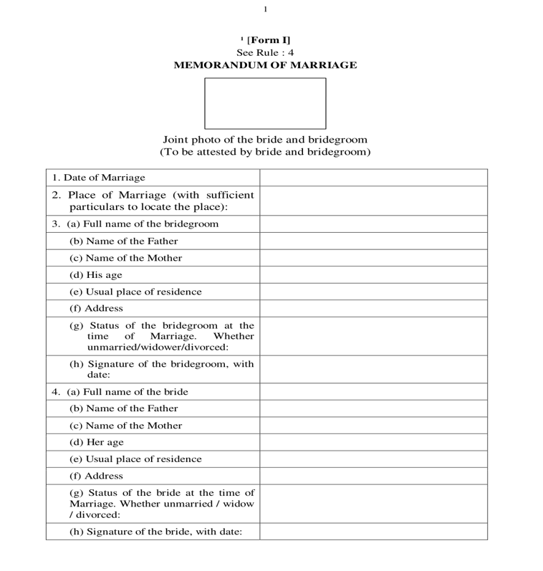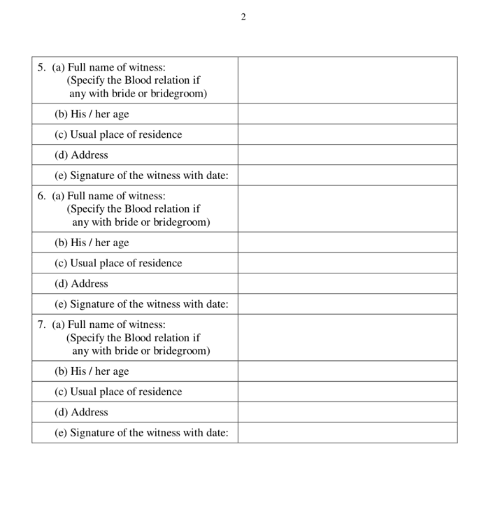
Form I — Memorandum of marriage (page 1 & 2).

Form IA

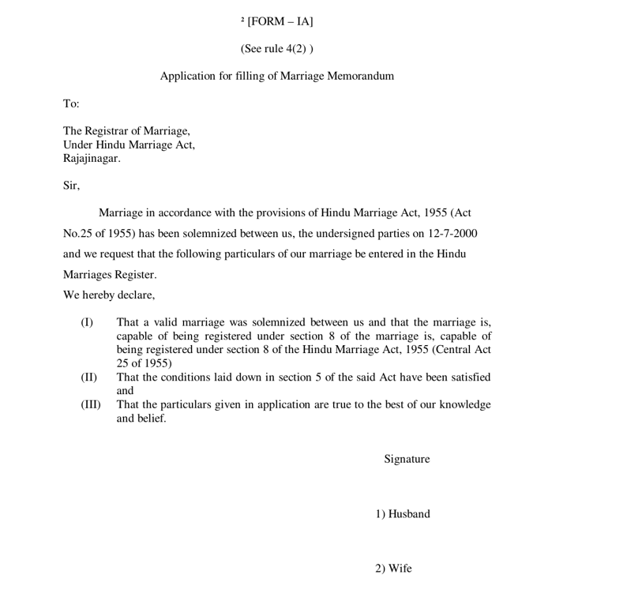
Form IA — Application for filing of marriage memorandum (Rule 4(2))

Form II — Not required in Kaveri 3.0

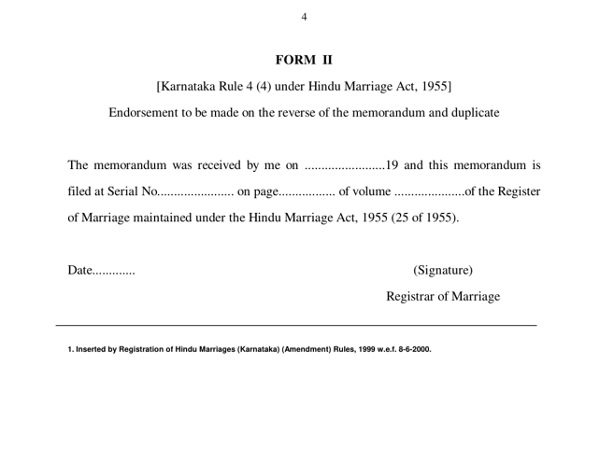
Form II (Endorsement — Rule 4(4)) is not required in Kaveri 3.0. Serial no., page and volume are assigned electronically when the Sub-Registrar digitally signs and Form II-A is issued. Legacy Form II specimen retained below for reference only.

Form II - A

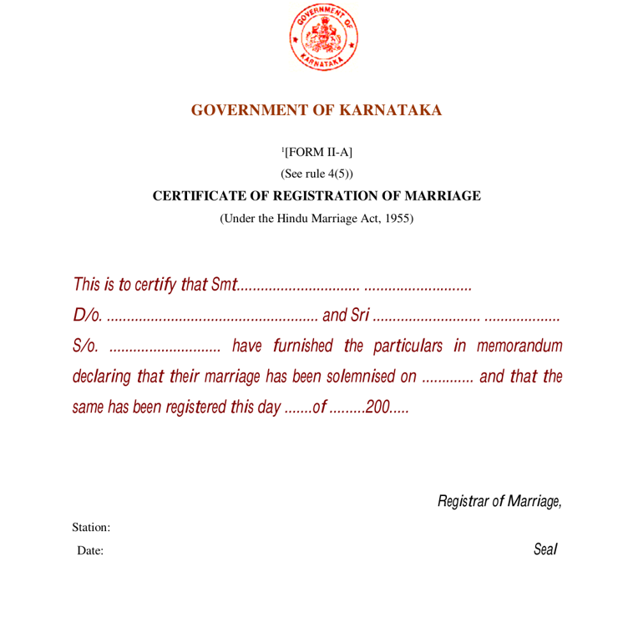
Form II-A — Certificate of registration of marriage (Rule 4(5)).

Statutory penalty highlights — Sec. 17 & Sec. 18 (displayed in red at submission)
The following extracts from the Hindu Marriage Act, 1955 shall be shown to the parties in red highlight panels when Form I / Form IA is submitted (Online and Offline) — see FR-HMA-091. Wording below is the statutory reference text for legal review; UI may abbreviate for readability without altering legal meaning.

- Sec. 17 — Punishment of bigamy: Any marriage between two Hindus solemnized after the commencement of this Act is void if at the date of such marriage either party had a husband or wife living; and the provisions of sections 494 and 495 of the Indian Penal Code (45 of 1860), shall apply accordingly.
- Sec. 18 — Punishment for contravention of certain other conditions for a Hindu marriage: Contravention of section 5(iii) (minimum age — bridegroom 21 years, bride 18 years): imprisonment which may extend to two years, or fine which may extend to one lakh rupees, or both. Contravention of section 5(iv) (degrees of prohibited relationship) or section 5(v) (sapinda relationship): simple imprisonment which may extend to one month, or fine which may extend to one thousand rupees, or both.

Special Marriage statutory forms mapping
Schedules under the Special Marriage Act, 1954 and forms under the Special Marriage (Karnataka) Rules, 1961
Form / Schedule | Act ref | Purpose | Generated by
Notice of Intended Marriage (Second Schedule) | Sec. 5 / Sec. 6 | Statutory notice for Intended Marriage | System + SR generation; portal / notice-board publication
Declarations (Third Schedule) | Sec. 11 | Declarations by parties and witnesses before solemnization | System / office capture
Certificate of Marriage (Fourth Schedule) | Sec. 13 | Certificate after solemnization under Chapter II | System on SR DSC
Certificate of Marriage (Fifth Schedule) | Sec. 16 | Certificate for marriages registered under Chapter III (Other Forms) | System on SR DSC
Form I / II (Karnataka Rules) | Rule 6(4) | Notice / summons for objection enquiry | System on objection workflow
Form III (Karnataka Rules) | Rule 7(1) | Application for registration of marriage celebrated in other forms | System on Other Forms path
Form IV (Karnataka Rules) | Rule 11 | Certified copy of entries transmitted to Registrar-General | Back-office quarterly export

Form - Notice of Intended Marriage
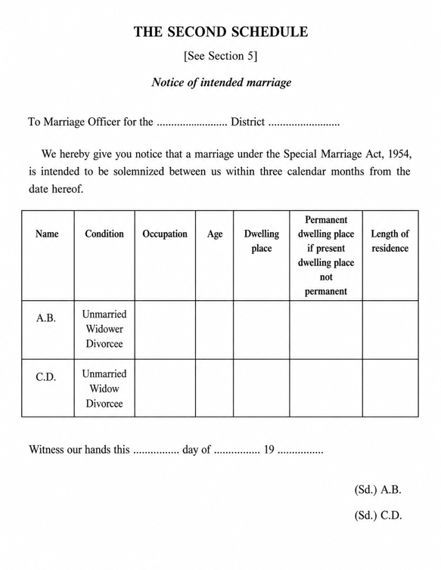
Second Schedule — Notice of intended marriage (Sec. 5 / Sec. 6).

Form - Declaration

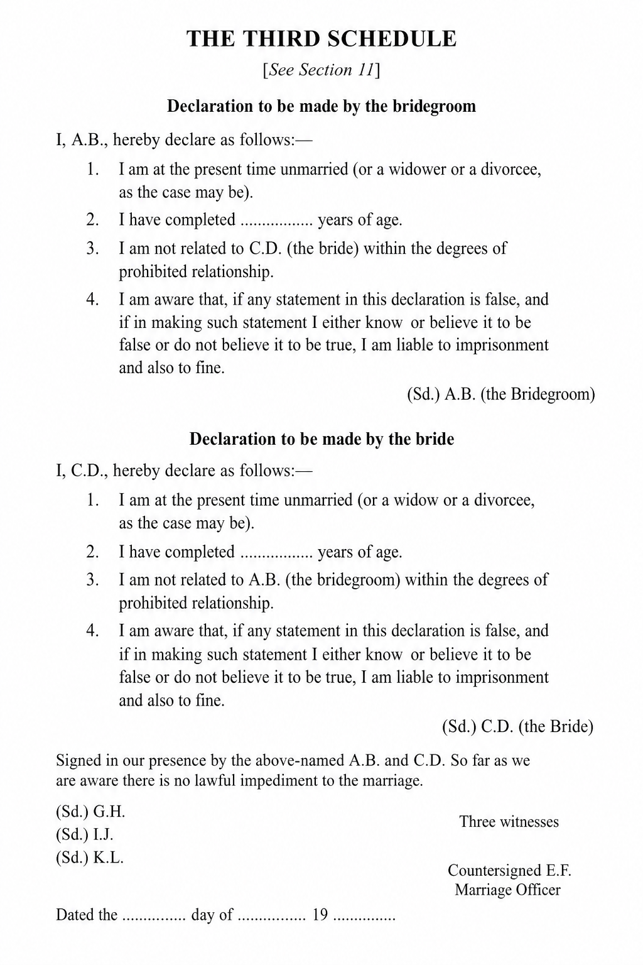
Third Schedule — Declarations by parties and witnesses (Sec. 11).

Form – Certificate – Special Marriage

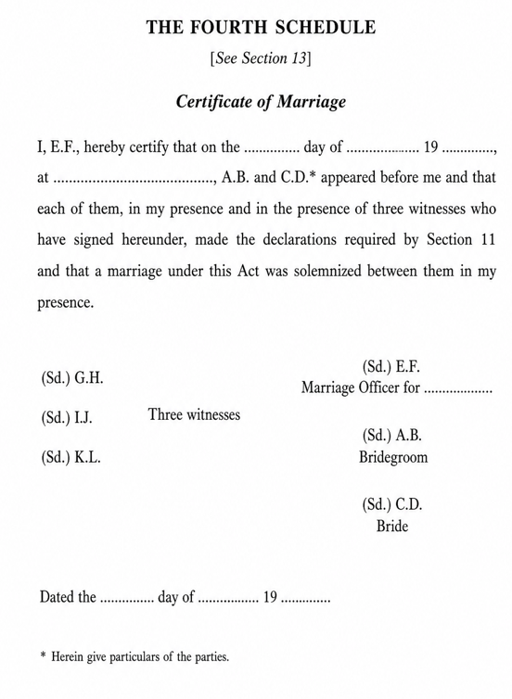
Fourth Schedule — Certificate of marriage after solemnization (Sec. 13).

Form – Certificate – Special Marriage (Other Forms)

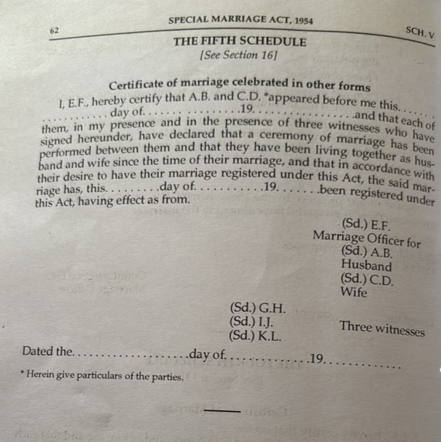
Fifth Schedule — Certificate of marriage celebrated in other forms (Sec. 16). Source: Acts_Rules/Marriage/SpecialOtherFormsCertificate.jpeg

Parsi Marriage statutory forms mapping
Schedule under the Parsi Marriage and Divorce Act, 1936. Source: Acts_Rules/Marriage/THE PARSI MARRIAGE AND DIVORCE ACT, 1936.pdf and Acts_Rules/Marriage/Parsi (scanned Act, Karnataka Rules and notification).
Form / Schedule | Act ref | Purpose | Generated by
Certificate of Marriage (Schedule II) | Sec. 6 | Certificate of marriage completed by the officiating priest immediately on solemnization, signed by the priest, both parties and two witnesses; basis for the Registrar's entry in the marriage register | Priest-issued (outside the portal); scanned / uploaded by the citizen (Online) or by the DEO (Offline); system captures the certificate reference on SR registration

Certificate of Marriage (Schedule II)
Schedule II — Certificate of Marriage (Sec. 6). Source: Acts_Rules/Marriage/Parsi/PageNo7.jpeg
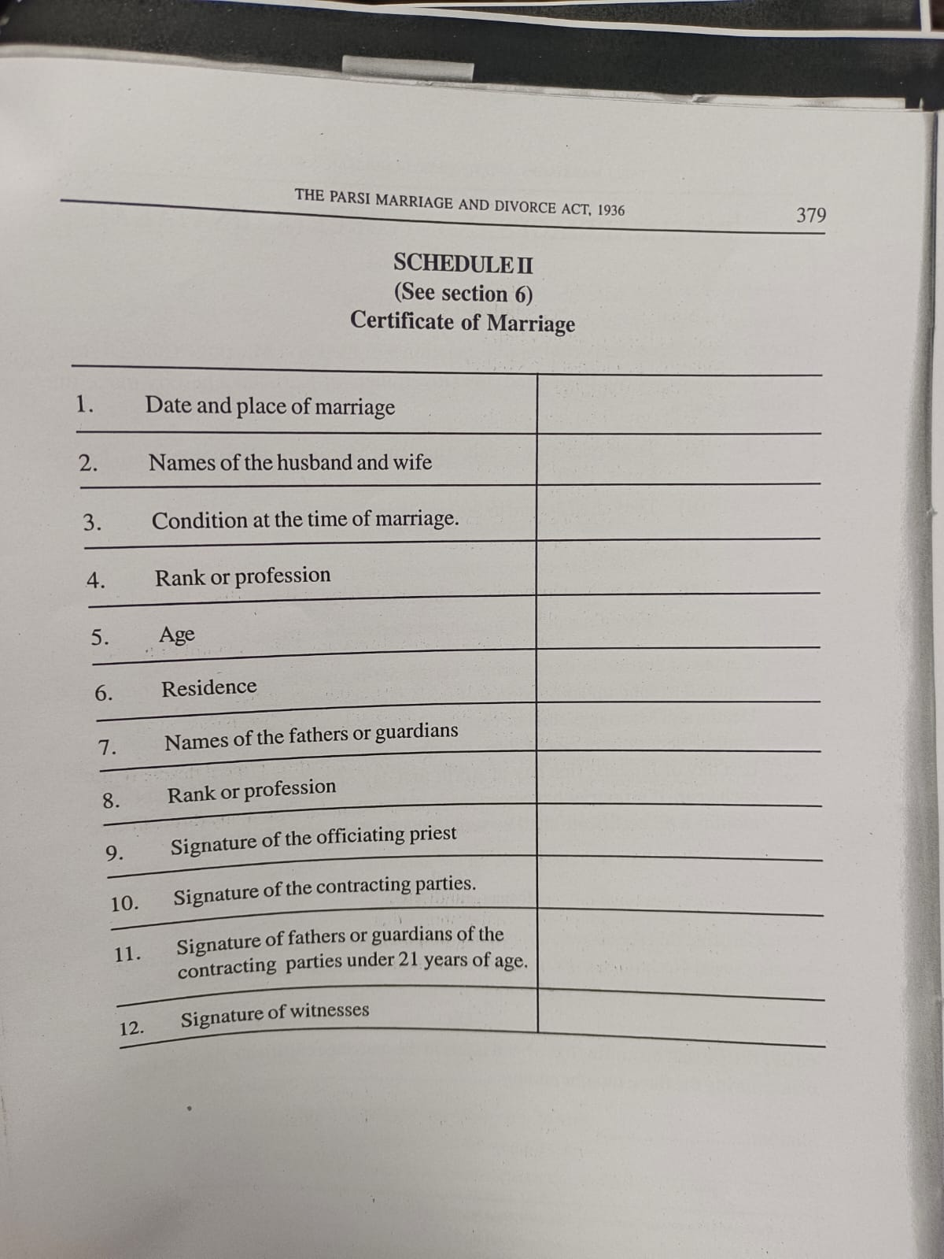

Sakala — Karnataka Guarantee of Services
Source: 3.i (Karnataka Act 1 of 2012); 3.ii.3 (selected sections); 3.iii.3 (Rules, 2012); Sakala Mission portal — https://sakala.kar.nic.in/. Marriage registration services offered through the Department of Stamps and Registration are notified Sakala services. Every eligible application shall receive a Guarantee of Services to Citizen (GSC) number so citizens can track status, receive time-bound service and file appeals (Appeal-I / Appeal-II) when service is delayed or rejected.
Notified marriage-related Sakala services (department baseline — confirm codes with Sakala Mission during integration design):
- Hindu Marriage registration (online filing) — GSC issued on successful fee payment; statutory service timeline commences from payment date (typically 1 working day for certificate delivery after payment, per department practice).
- Special Marriage — Intended Marriage notice and registration.
- Special Marriage — Other Forms notice and registration.
Kaveri 3.0 shall integrate with the Sakala platform per NIC / Sakala Mission approved web methods for GSC registration, status updates (acceptance, in-process, delivered, rejected), party-detail upload and orphan-settle retry — see 8.7 and 11. (FRS and NFR document)

Stakeholders and actors
Actor | Description | Primary goals | Channel involvement
Bride / Bridegroom (citizens/applicant) | Parties to marriage | Sign declarations, provide documents | Online: eSign; Offline: physical signature on printed Form I / IA / II-A
Witness (×3) | Present at solemnization | Identity, address, signature on memorandum | Online: eSign / e-KYC / Face Authentication [TBD]; Offline: physical signature
Marriage Registrar / Sub-Registrar (SR) | Statutory registrar | Verification, register, digital signature, refuse with order | Online: single verification; Offline: two verification stages
Data Entry Operator (DEO) | SRO-office operator handling physically signed forms | Check signatures on printed Form I / IA / II-A and upload to portal | Offline only
Treasury / payment gateway | Fee collection | e-Payment, Reconciliation | Both (payment triggered after first SR approval)
eSign / DSC service provider | Digital signing | Citizen eSign (online), SR digital signature (both) | Both
Domain Expert | Validation | Sign-off on rules and forms | Review workshops
Sakala (Karnataka Guarantee of Services) | Statutory time-bound service delivery platform (Sakala Mission / NIC) | Issue GSC on acceptance/payment; track statutory timelines; sync lifecycle (in-process / delivered / rejected); citizen tracking and appeals | Both (GSC and status sync for Online and Offline Hindu / Special Marriage services)

Definitions and glossary
Term | Definition
Memorandum | Form I particulars of marriage
Registrar | Registrar of Hindu Marriages (Sub-Registrar)
Register | Paste-book Hindu Marriage Register (Bride/Groom Registers)
Solemnization | Performance of customary rites (Section 7)
Hindu Marriage Online | Channel where citizen selects Online first, completes combined prerequisite+declaration, captures details with e-KYC / Face Authentication/Face Authentication on Bride, selects office, submits Form 1 with eSign; no physical form submission
Hindu Marriage Offline | Channel where citizen selects Offline first, completes combined prerequisite+declaration, captures details, undergoes SR Stage 1, pays and books appointment, prints Form I, SR allocates to DEO for signature check and upload, then SR Stage 2 and DSC
eSign | Electronic signature applied by citizen on Form I (Memorandum) and Form IA (Application) in the Online channel
SR digital signature (DSC) | Digital signature applied by Sub-Registrar before certificate issuance (both channels)
SR Verification | Sub-Registrar scrutiny decision (Approve / Reject). Offline has two occurrences: pre-payment data verification and post-upload signed-form verification; Includes Refuse with reason and order before registration / solemnization (FR-HMA-103/104; FR-SMA-073)
Data Entry Operator (DEO) | Checks signatures on the printed forms and uploads them to the portal (Offline only)
Appointment | Scheduled SRO visit slot booked by the citizen together with payment in the Offline channel
Special Marriage (Intended Marriage) Notice | Chapter II notice of intended marriage under SMA 1954 Sec. 5–7; Online or Offline notice generation before solemnization
Special Marriage (Intended Marriage) Registration | Post-notice solemnization & certificate issuance when timeline ≥30 and ≤90 days and no valid objection
Special Marriage Other Forms | Chapter III registration of marriages celebrated in other forms (SMA Sec. 15–16), with notice publication and objection period
Marriage Notice Book | Statutory book in which notices under Sec. 5 / Sec. 16 are entered and open to inspection (Sec. 6)
30-day countdown | Statutory objection / waiting period from notice publication (Sec. 7 / Sec. 16)
First Payment / Second Payment | Fee collected at notice stage (first) and at registration/solemnization stage (second) per Karnataka Special Marriage fee schedule
GSC (Guarantee of Services to Citizen) | Unique Sakala acknowledgement number issued for notified services; enables citizens to track application status and file appeals at https://sakala.kar.nic.in/
Sakala | Karnataka Guarantee of Services to Citizens programme (Act, 2011); mandates time-bound delivery and accountability for notified government services

Current state

As-Is pain points
Pain points evidenced from Kaveri 2.0 workshops, ServiceDesk tickets and department discussions. The Addressed in column maps each item to the To-Be process in this BRD (7) and to functional / non-functional requirements, fallbacks and risks in this document (8–11).
Sr.No | Pain Point | Description | Source | Addressed in (this BRD)
1 | Not mobile-friendly | The application is not usable on mobile browsers, limiting citizen access on phones and tablets. | Discussion | BRD 7.vi (UI/UX); 7.i.a / 7.ii.a Online channels; 8.xi UI; 9.iv NFR-MRG-VAPT-002 (mobile-responsive interfaces)
2 | Incorrect address on certificate | Sub-district is incorrectly included in the address shown on the marriage certificate. | Discussion | BRD 7.i.b.A common intake (party address); 7.i.b.B / 7.i.b.C certificate issuance; 8.i.c–8.i.e; FR-HMA-008, FR-HMA-010/011; 8.i.p FR-HMA-030/080/081
3 | Complex area/village selection | Selecting area or village is cumbersome and difficult for applicants to complete accurately. | Discussion | BRD 7.i.b.A common intake (jurisdiction / area selection); 8.i.b; FR-HMA-005, FR-HMA-008; 8.xii Integrations (MDM / address master)
4 | Restrictive document upload rules | Uploaded image file size is too small, and mandatory pixel/dimension checks block valid uploads. | Discussion | BRD 7.i.b.A common intake (supporting documents); 8.i.i; FR-HMA-065, FR-HMA-018/019
5 | Missing Save action for Witness 3 | The 'Save Witness 3' action is missing from the workflow. | Discussion | BRD 7.i.b.A common intake (witnesses); 8.i.f; FR-HMA-012–014; BR-HMA-001
6 | Edit does not return to correct step | Using Edit from an in-progress marriage application does not open the latest or relevant step (e.g., Marriage Details screen). | Discussion | BRD 7.i.b.D Application Status Model; 8.i.o; FR-HMA-073/074; BR-HMA-014, BR-HMA-017
7 | Documents not visible during scrutiny | Supporting documents uploaded with the application are not reliably visible to marriage registrar during application scrutiny. | Discussion | BRD 7.i.b.B Online / 7.i.b.C Offline (SRO scrutiny); 8.i.k; FR-HMA-026
8 | No edit flexibility before payment | Applicants cannot freely go back to earlier steps and edit data. | Discussion | BRD 7.i.b process (edit until payment / eSign gate); 8.i.m; FR-HMA-052; BR-HMA-010
9 | No processing priority order | Applications are not handled in first-in, first-out (FIFO) order, affecting fairness and turnaround time. | Discussion | BRD 7.i.b.D Application Status Model (officer queue); 8.i.k; FR-HMA-077; 8.vii FR-HMA-042 (cycle-time MIS)
10 | Password-protected uploads not handled | The system accepts or fails unclearly on password-protected documents instead of blocking them with a clear message. | Discussion | BRD 7.i.b.A common intake (document upload validation); 11 FB-MRG-003; 8.i.i FR-HMA-065
11 | Limited notification channels | Notifications are not sent through both SMS and email as expected by the citizens and officers. | Discussion | BRD 7.i.b / 7.ii.b process; 7.vi (payments and notifications); 8.vi; FR-HMA-036–038; FR-SMA-054; FB-MRG-004
12 | No operational dashboard visibility | There is no dashboard showing daily registration count, pending applications, or processed applications. | Discussion | BRD 7.vi What is new in Kaveri 3.0; 8.vii; FR-HMA-041–045; FR-SMA-055–058
13 | Wrong DEO allocation and no reassignment | Applications are frequently allocated to the wrong DEO by mistake. Officers cannot return, reassign, clear, or remove applications from DEO login without ServiceDesk intervention (~66 tickets; 8 in last 3 months — still active). | Service Desk | BRD 7.i.b.C Offline (SR allocates / reassigns DEO); 8.i.n; FR-HMA-069, FR-HMA-088; 10 RS-MRG-003
14 | Notice workflow state errors | After notice period completion, the system still shows Generate Notice or Print Notice instead of advancing. Notice steps reappear after second payment. | Service Desk | BRD 7.ii.b.D / 7.iii.b.C Application Status Model; 8.ii.h; FR-SMA-019–032, FR-SMA-024–026
15 | Blank challan / verify-challan loop | Citizen payment fails because the portal shows Verify Challan with a blank challan, forcing repeated payment attempts and helpdesk tickets (~38 tickets). | Service Desk | BRD 7.i.b.B / 7.ii.b.B Online payment; 7.vi (payments); 8.i.j; 11 FB-MRG-001; NFR-MRG-PAY-001; FR-HMA-025, FR-SMA-052
16 | Stuck on summary page — cannot go to next step | Users cannot proceed past the summary/review page to the next workflow step, leaving applications blocked mid-process (~41 tickets). | Service Desk | BRD 7.i.b / 7.ii.b.B process (summary → next step); 8.i.m; FR-HMA-051, FR-HMA-052; FR-SMA-012; FR-HMA-038
17 | DOB and party details not reflecting | Date of birth and related bride/bridegroom details entered in the application do not reflect on subsequent screens or the certificate (~21 tickets). | Service Desk | BRD 7.i.b.A / 7.ii.b.A party particulars; 8.i.d–8.i.e; 8.2.3; FR-HMA-058, FR-HMA-089; FR-SMA-009/062/063/066
18 | Place of marriage missing in summary/report | Place of Marriage captured during data entry does not appear in the review summary page or summary report (~12 tickets; also listed in curated issues list). | Service Desk | BRD 7.i.b.A / 7.ii.b.A marriage details (place of marriage); 8.i.c; 8.2.2; FR-HMA-017; FR-HMA-051
19 | Cross-reference to registered marriage missing | There is no usable provision to add cross-references to a registered marriage. Multiple recent tickets (May–Jun 2026) request this repeatedly. | Service Desk | BRD 7.vi What is new in Kaveri 3.0 (post-registration search); 8.v; FR-HMA-034; 8.xiii.a Core entities
20 | Signatures missing on digitally signed certificate | After digital signing, bride, bridegroom, and witness signatures do not appear on the generated certificate | Service Desk | BRD 7.i.b.B Online DSC / certificate; 7.iii.b.B solemnization & certificate; 8.i.p; 8.iii.c; FR-HMA-054/080; FR-SMA-040/048; BR-HMA-001, BR-SMA-011
21 | Notice number and notice date not displaying | Notice number and notice date do not show on the relevant screens after notice generation, affecting verification and further processing (repeated in last 3 months). | Service Desk | BRD 7.ii.b notice generation / publication; 7.ii.b.D status model; 8.ii.e–8.ii.g; FR-SMA-014/016/021; FR-SMA-055

Future state (To-Be)
The Marriage Registration To-Be model is organized by service. Each service documents its Channel models, Process Diagram (Common intake steps, Online and/or Offline (In Person) flows) and Application Status Model. The module covers Hindu Marriage (Online / Offline) and Special Marriage notice generation (Intended Marriage and Other Forms share one workflow) followed by marriage registration (shared workflow with path-specific timeline and certificate-schedule branches). Notice channels are initiated through the citizen portal; registration is completed In Person at the Sub-Registrar office.

Hindu Marriage

Channel models
Hindu Marriage supports Online and Offline (In Person) channels. Channel is selected before prerequisites and drives subsequent screens, payment timing and office tasks.
Service Type | Online Activities | Office Activities | Mode
Hindu Marriage Online | Registration, e-KYC / Face Authentication (Bride), eSign, Payment (post-approval), Tracking | Verification, DSC | Online
Hindu Marriage Offline | Registration, Payment, Appointment Booking, Printout | SR Stage 1, SR→DEO allocation, Form upload, SR Stage 2, DSC | Offline

Process Diagram

Common intake steps
Identical in both Hindu Marriage diagrams (Citizens and System lanes):
- START — citizen initiates the service.
- LogOn to Portal — authenticated citizen session.
- Start a new Application.
- Marriage Registration — citizen selects the marriage registration service.
- Select channel: Hindu Marriage Online / Hindu Marriage Offline. Channel is chosen before prerequisites.
- Read and continue with Prerequisite for marriage and complete declaration — single combined acknowledgement screen (eligibility, documents, channel implications and statutory declarations). SR rejection of the notice application returns here for correction and resubmission.
- Enter / capture Marriage details, Bride details, Bridegroom details, Witness details — persisted to the application record. Online channel: e-KYC / Face Authentication on Bride details (see 7.i.b.B). Offline channel: whether Aadhaar information is available — if yes, e-KYC / Face Authentication on Bride & Bridegroom details; if no, manual data entry (see 7.i.b.C). This step is the re-entry point for SR rejection loops that return to citizen data entry in both diagrams.

Online
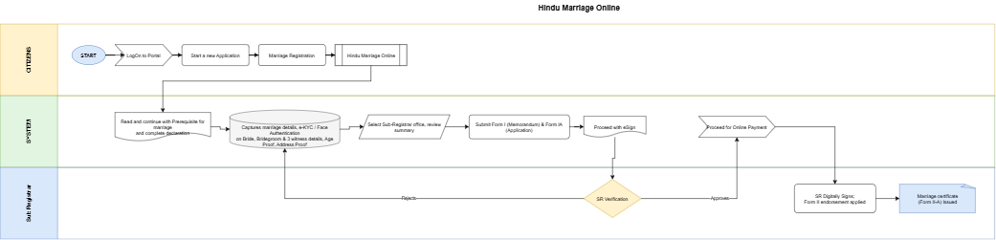

Figure: Hindu Marriage Online process
Flow (continuing from 7.i.b.A step 7 — Online-specific steps):
# | Step | Lane | Notes
7 | Capture marriage / e-KYC / Face Authentication/Face Authentication on Bride details / Bridegroom / 3 witness details | System / Citizen | Per Online diagram: e-KYC / Face Authentication applied on Bride details during capture (Bridegroom e-KYC / Face Authentication)
8 | Select Sub-Registrar office and review summary of updated information | System / Citizen | Jurisdiction routing
9 | Submit Form I (Memorandum) and Form IA (Application) | System / Citizen | Form I & Form IA generated for the selected office
10 | Proceed with eSign | System / Citizen | Citizen eSign on Form I and Form IA
11 | SR Verification (decision) | Sub Registrar | Approve or Reject
11a | Reject → return to Enter Marriage / Bride / Bridegroom / Witness details | Sub Registrar → System | Citizen corrects and resubmits; refusal reason recorded
12 | Proceed for Online Payment | System / Citizen | Payment occurs only after SR approval
13 | SR Digitally signs | Sub Registrar | DSC applied
14 | Serial/page/volume assigned; marriage certificate (Form II-A) generated | Sub Registrar / System | Form II-A available for download (register endorsement electronic; Form II not used)

Key characteristics: channel before combined prerequisite+declaration; e-KYC / Face Authentication on Bride details during capture; office selection + summary; Form I & Form IA + eSign; SR digital signature assigns serial/page/volume and issues Form II-A certificate (no Form II); no printout, no appointment, no DEO; single SR verification; payment only after SR approval; fully digital signature chain.

Offline (In Person)
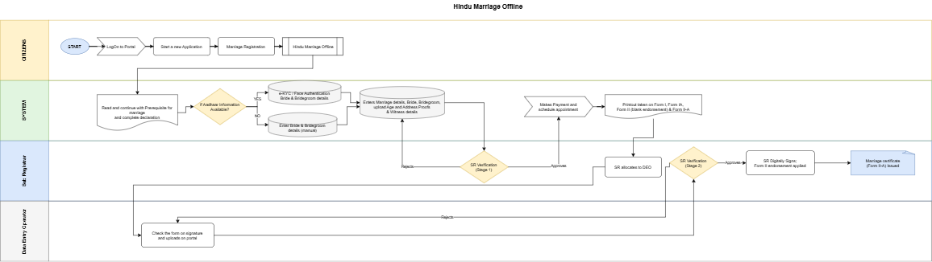

Figure: Hindu Marriage Offline process
Flow (continuing from 7.i.b.A step 7 — Offline-specific steps):
# | Step | Lane | Notes
7 | Whether Aadhaar information available? If Yes → e-KYC / Face Authentication on Bride & Bridegroom details; else Enter Bride & Bridegroom details (manual) | System / Citizen | Per Offline diagram (Aadhaar YES/NO branch); witness details captured with party particulars
8 | SR Verification — Stage 1 (decision) on captured application data | Sub Registrar | Approve or Reject
8a | Reject → return to Enter Marriage / Bride / Bridegroom / Witness details | Sub Registrar → System | Citizen corrects and resubmits
9 | Makes Payment and schedule appointment | System / Citizen | Payment and slot booking in one step, after Stage 1 approval
10 | Printout taken on Form I, Form IA and Form II-A (Form II not required) | System / Citizen | Citizen prints the statutory forms per Karnataka Hindu Marriage forms
11 | SR allocates to DEO | Sub Registrar | Explicit allocation step per updated Offline diagram before DEO upload
12 | Parties and witnesses sign physically; citizen attends the SRO on the appointment date | Citizen (offline activity) | Not a system step; precondition for DEO upload
13 | Check the form on signature and uploads on portal | Data Entry Operator | DEO verifies signatures are present/complete, scans and uploads
14 | SR Verification — Stage 2 (decision) on the uploaded signed forms | Sub Registrar | Approve or Reject
14a | Reject → return to DEO check / upload step | Sub Registrar → DEO | Re-check or re-upload; does not go back to citizen data entry
15 | SR Digitally Signs | Sub Registrar | DSC applied
16 | Marriage certificate Issued | Sub Registrar / System | Form II-A issued

Key characteristics: channel before combined prerequisite+declaration; whether Aadhaar available — e-KYC / Face Authentication on Bride & Bridegroom or manual data entry (Aadhaar YES/NO branch); SR Verification Stage 1 on captured data before payment; payment + appointment bundled; printout of Form I, Form IA, Form II-A (no Form II blank endorsement); SR allocates to DEO; DEO signature check and upload; SR Verification Stage 2 on uploaded signed forms (reject returns to DEO); SR DSC assigns serial/page/volume then issues Form II-A certificate.

Application Status Model
Channel-aware application statuses for Hindu Marriage Online and Offline:
Status | Description | Actor | Next states
Draft | Saved not submitted | Citizen | Channel selected
Channel selected | Online or Offline chosen (before prerequisites) | Citizen | Prerequisite & declaration completed
Prerequisite & declaration completed | Combined prerequisite + declaration acknowledged | Citizen | Details captured
Details captured | Marriage / bride / bridegroom / witness details saved (Online: e-KYC / Face Authentication on Bride details; Offline: e-KYC / Face Authentication on Bride & Bridegroom when Aadhaar available, else manual) | Citizen | Office selected (Online) / Pending SR verification Stage 1 (Offline)
Office selected & summary reviewed | SRO office chosen, summary confirmed | Citizen | Form I & Form IA submitted
Form I & Form IA submitted | Form I (Memorandum) and Form IA submitted | Citizen | eSign pending
eSign pending | Awaiting citizen eSign | Citizen | Pending SR verification
Pending SR verification | Awaiting SR scrutiny | SR | Approved for payment / Rejected — data
Rejected — data correction | Sent back to citizen data entry | SR | Details captured
Approved for payment | SR approved; fee payable | SR | Payment completed
Payment completed | Fee paid, receipt issued | System | Pending SR digital signature (Online) / Appointment scheduled (Offline)
Appointment scheduled | SRO visit slot booked | Citizen | Forms printed
Forms printed | Form printout taken | Citizen | Allocated to DEO
Allocated to DEO | SR has allocated the application to a DEO | SR | Awaiting signed-form upload
Awaiting signed-form upload | Physically signed forms pending at SRO | Citizen / DEO | Signed forms uploaded
Signed forms uploaded | DEO checked signatures and uploaded | DEO | Pending SR verification — Stage 2
Pending SR verification — Stage 2 | Awaiting SR scrutiny of signed forms | SR | Pending SR digital signature / Rejected — upload
Rejected — upload | Sent back to DEO for re-check / re-upload | SR | Signed forms uploaded
Pending SR digital signature | Awaiting DSC | SR | Registered
Registered | Serial / page / volume assigned (electronic register; no Form II) | SR | Certificate issued
Certificate issued | Form II-A Generated / downloadable | System | Closed
Closed | No further action | System | —

Special Marriage Notice Generation (Intended Marriage / Other Forms)
Intended Marriage (Chapter II) and Other Forms (Chapter III) share a single notice-generation workflow. After Marriage Registration the citizen answers Whether Marriage already taken place or not?: No routes to Special Marriage (Intended Marriage Notice); Yes routes to Special Marriage (Other Forms Notice) and then Enter Marriage Details (date, place and form / rites of the already celebrated ceremony) before Prerequisite. Both paths then share Prerequisite; party capture (Online: mandatory e-KYC / Face Authentication; Offline: Aadhaar YES/NO branch or manual); Online or Offline publication; first payment; eSign / notice-board and the 30-day countdown.

Channel models
Notice generation supports Online and Offline (In Person) channels for both Intended Marriage and Other Forms. The selected notice channel drives publication mode (portal vs notice board) and office tasks. Service path (Intended Marriage vs Other Forms) is decided by Whether Marriage already taken place or not? immediately after Marriage Registration; Other Forms additionally captures marriage details before Prerequisite.
Service Type | Online Activities | Office Activities | Mode
Special Marriage Notice — Online (Intended Marriage / Other Forms) | e-KYC / Face Authentication bride & bridegroom, document upload (incl. photos), First Payment, portal notice, eSign | SR verification; System notice generation (no DEO / appointment) | Online notice
Special Marriage Notice — Offline (Intended Marriage / Other Forms) | Capture details (e-KYC / Face Authentication when Aadhaar available, else manual), document upload, First Payment, appointment | SR verification, notice generation, DEO photo/print/sign/scan/upload, paste on notice board | Offline notice

Process Diagram

Common intake steps
Identical in both notice diagrams (Citizens and System lanes). Intended Marriage and Other Forms share these steps through Prerequisite (step 7); the path decision and Other Forms Enter Marriage Details branch are in steps 5–6. Party capture continues per the Online (7.ii.b.B) or Offline (7.ii.b.C) notice diagram:
- START — citizen initiates the service.
- LogOn to Portal — authenticated citizen session.
- Start a new Application.
- Marriage Registration — citizen selects the marriage registration service.
- Whether Marriage already taken place or not? — No: Special Marriage (Intended Marriage Notice); Yes: Special Marriage (Other Forms Notice). Online vs Offline is the selected notice channel (separate diagrams 7.ii.b.B / 7.ii.b.C). Marriage Registration (certificate) is initiated later by selecting an approved notice (see 7.iii).
- If Other Forms (Yes): Enter Marriage Details — date, place and form / rites of the already celebrated ceremony (not required for Intended Marriage). Both paths then continue to Prerequisite.
- Read and continue with Prerequisite for marriage and complete declaration — single combined acknowledgement screen (eligibility, documents, channel implications and statutory declarations). SR rejection of the notice application returns here for correction and resubmission.

Online
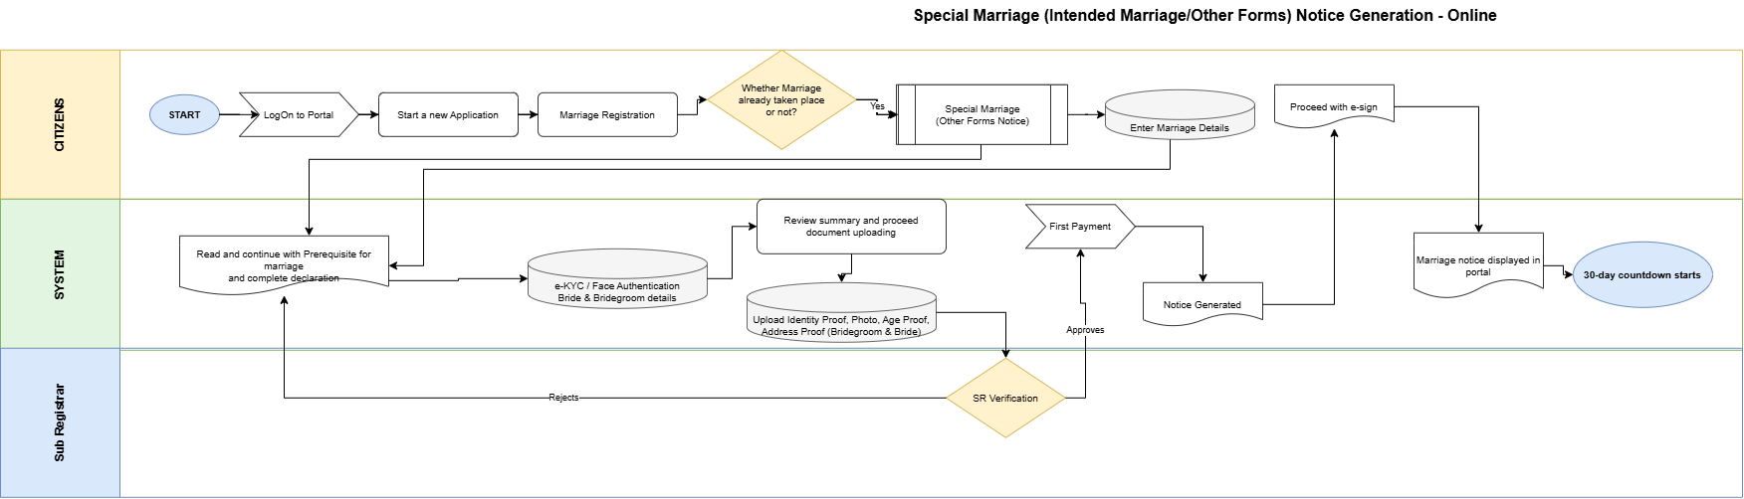
Figure: Special Marriage (Intended Marriage/Other Forms) Notice Generation — Online
Flow (continuing from 7.ii.b.A step 7 — Online notice-specific steps; shared by Intended Marriage and Other Forms):
# | Step | Lane | Notes
8 | e-KYC / Face Authentication on Bride & Bridegroom details | System / Citizen | Continues from 7.ii.b.A step 7; mandatory on Online notice diagram (no manual path)
9 | Review summary and proceed document uploading | System / Citizen | Summary of captured particulars
10 | Upload Identity Proof, Photo, Age Proof, Address Proof (Bridegroom & Bride) | Citizen | Mandatory supporting documents including individual photographs
11 | SR Verification (decision) | Sub Registrar | Approve or Reject
11a | Reject → return to Prerequisite & declaration | Sub Registrar → Citizen | Citizen corrects and resubmits (diagram returns to Prerequisite)
12 | First Payment | System / Citizen | Notice fee per Karnataka Special Marriage fee schedule
13 | Notice Generated | System | Statutory notice generated after first payment (no Online DEO / appointment)
14 | Proceed with e-sign | Citizen | Citizen eSign on the generated notice before portal publication
15 | Marriage notice displayed in portal | System | Sec. 6 publication (digital); follows e-sign per Online notice diagram
16 | 30-day countdown starts | System | Objection period per Sec. 7 / Sec. 16 from publication / portal display

Key characteristics (both paths): after the Whether Marriage already taken place or not? branch (Other Forms: Enter Marriage Details before Prerequisite), mandatory e-KYC / Face Authentication on Bride & Bridegroom; document upload including individual photos; SR verification before First Payment; System generates notice after payment; citizen e-sign on the generated notice; then Marriage notice displayed in portal; no Online appointment or DEO; 30-day countdown from publication (Sec. 7 / Sec. 16).

Offline (In Person)
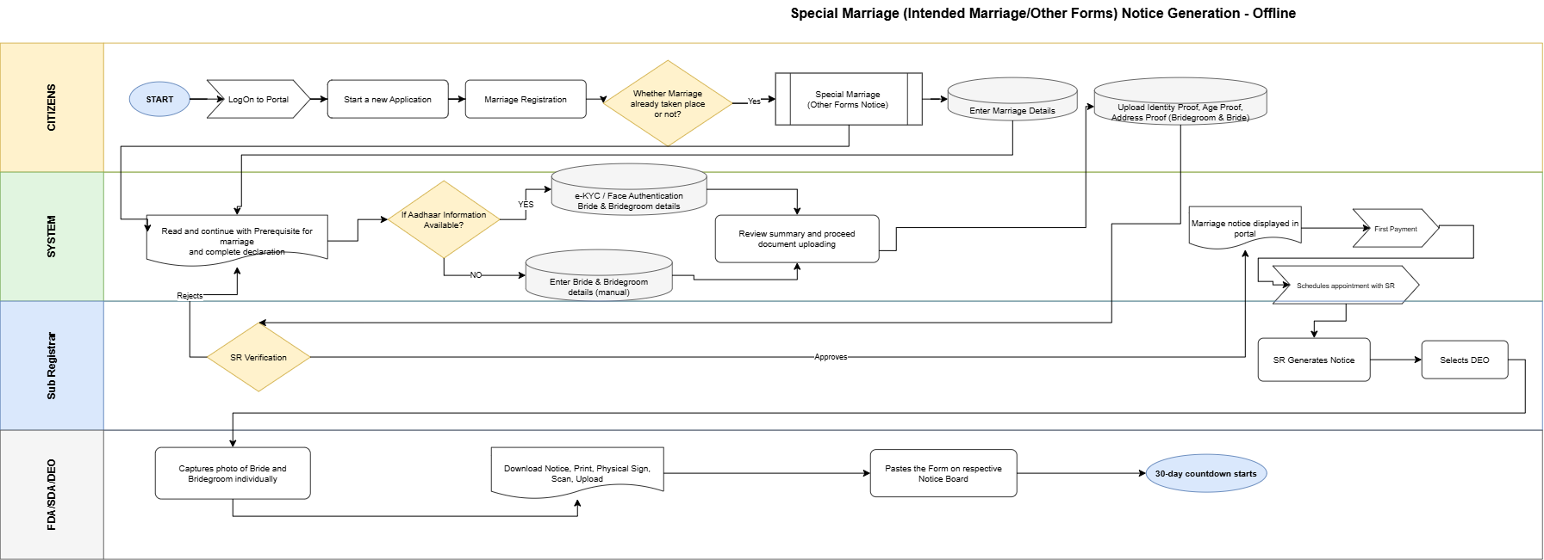
Figure: Special Marriage (Intended Marriage/Other Forms) Notice Generation — Offline
Flow (continuing from 7.ii.b.A step 7 — Offline notice-specific steps; shared by Intended Marriage and Other Forms):
# | Step | Lane | Notes
8 | If Aadhaar available → e-KYC / Face Authentication on Bride & Bridegroom details; else Enter Bride & Bridegroom details | System / Citizen | Continues from 7.ii.b.A step 7; per Offline notice diagram (Aadhaar YES/NO branch)
9 | Review summary and proceed document uploading | System / Citizen | Summary of captured particulars
10 | Upload Identity / Age / Address proofs (Bridegroom & Bride) | Citizen | Mandatory documents (individual photos captured later by DEO at office)
11 | SR Verification (decision) | Sub Registrar | Approve or Reject
11a | Reject → return to Prerequisite & declaration | Sub Registrar → Citizen | Citizen corrects and resubmits (diagram returns to Prerequisite)
12 | First Payment | System / Citizen | Notice fee
13 | Schedule appointment with SR | System / Citizen | After first payment
14 | SR Generates Notice | Sub Registrar | Statutory notice generation
15 | Selects DEO | Sub Registrar | Assign FDA/SDA/DEO
16 | Capture individual photos of Bride & Bridegroom | FDA / SDA / DEO | Office visit activity
17 | Download, Print, Sign, Scan and Upload notice | FDA / SDA / DEO | Physical notice processed into system
18 | Paste form on respective Notice Board | FDA / SDA / DEO | Sec. 6(2) conspicuous place publication; also drives portal display
19 | 30-day countdown starts | System | Objection period per Sec. 7 / Sec. 16

Key characteristics (both paths): after the Whether Marriage already taken place or not? branch (Other Forms: Enter Marriage Details before Prerequisite), Aadhaar YES (e-KYC / Face Authentication) / NO (manual) capture; SR verification → First Payment → appointment; SR generates notice & selects DEO; individual photo capture; physical notice-board paste (Sec. 6(2)) with portal display; 30-day countdown. SR rejection returns to Prerequisite & declaration.

Application Status Model
Application statuses for Special Marriage Notice Generation (Online / Offline; Intended Marriage and Other Forms):
Status | Description | Actor | Next states
Draft | Saved not submitted | Citizen | Channel selected
Channel selected | Online or Offline notice channel chosen (before prerequisites) | Citizen | Prerequisite & declaration completed
Prerequisite & declaration completed | Combined prerequisite + declaration acknowledged | Citizen | Details captured
Details captured | Online: bride / bridegroom particulars saved via mandatory e-KYC / Face Authentication. Offline: e-KYC / Face Authentication where Aadhaar available, else manual entry. Other Forms only: marriage details already saved at path selection (before Prerequisite) | Citizen | Notice application submitted
Notice application submitted | Special Marriage notice application submitted for SR scrutiny (documents and particulars complete; Online citizen eSign of the statutory notice occurs after Notice Generated — see Notice generated / Notice published) | Citizen | Pending SR verification — notice
Pending SR verification — notice | Awaiting Marriage Officer scrutiny of the notice application | SR | Notice approved / Rejected — notice data
Rejected — notice data | Returned to citizen for correction; flow returns to Prerequisite & declaration per notice diagrams | SR | Prerequisite & declaration completed
Notice approved | SR approved; first payment payable | SR | First payment completed
First payment completed | Notice fee paid, receipt issued | System | Notice generated
Notice generated | Statutory notice generated and entered in the Marriage Notice Book. Online: citizen eSign is performed on the generated notice before portal display | SR | Notice published (after Online e-sign where applicable)
Notice published | Published on portal after Online e-sign, or pasted on notice board after DEO upload (Offline); publication timestamp starts the countdown | System / DEO | Objection period running
Objection period running | 30-day statutory countdown in progress | System | Notice valid for registration / Objection filed
Objection filed | Objection recorded in the Marriage Notice Book | Public / SR | Under objection enquiry
Under objection enquiry | SR enquiry by summoning parties (decide within 30 days) | SR | Objected — closed / Notice valid for registration
Objected — closed | Objection upheld; notice removed from portal and tagged Objected | SR | Closed
Notice valid for registration | Path-specific: Intended Marriage — notice ≥ 30 and ≤ 90 days with no valid objection; Other Forms — notice ≥ 30 days with no valid objection | Citizen | Proceed to Marriage Registration (see 7.iii)
Notice expired | Validity window lapsed; fresh notice required | System | Closed
Closed | No further action | System | —

Special Marriage Marriage Registration (Intended Marriage / Other Forms)
Intended Marriage and Other Forms share a single registration workflow after notice publication. Path-specific branches: (1) timeline gate — Intended Marriage ≥ 30 and ≤ 90 days from publication; Other Forms ≥ 30 days (no ≤ 90 upper gate in the Other Forms registration diagram); (2) certificate schedule — Fourth Schedule after Chapter II solemnization vs Fifth Schedule after Chapter III registration.

Channel models
Marriage Registration continues from an approved / published notice after the statutory waiting period. Completion is Offline (In Person) at the Sub-Registrar office (solemnization or Chapter III registration, DEO certificate production and SR DSC). There is no separate fully-online registration channel.
Service Type | Online Activities | Office Activities | Mode
Special Marriage Marriage Registration (Intended Marriage / Other Forms) | Select approved notice (Intended: ≥30 & ≤90 days; Other Forms: ≥30 days), Second Payment, schedule visit, download certificate | Objection enquiry (if any), SR verification, DEO joint photo / witness / declaration / certificate, solemnization or Chapter III registration, SR DSC | Registration (In Person)

Process Diagram

Common intake steps
Portal and office steps are the same for Intended Marriage and Other Forms except the timeline gate and the certificate schedule. The process table in 7.iii.b.B is the authoritative step list; path-specific branches are in the Notes column.

Offline (In Person)
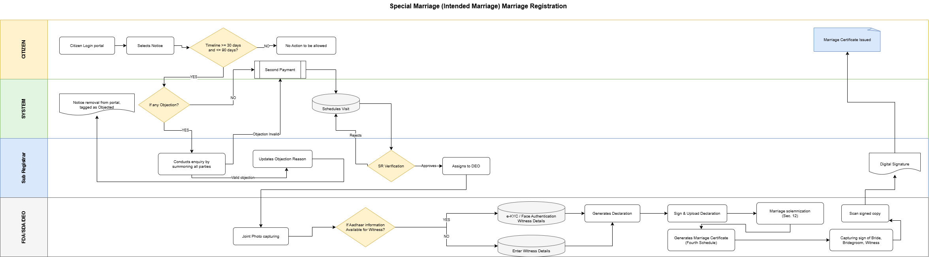

Figure: Special Marriage (Intended Marriage) Marriage Registration
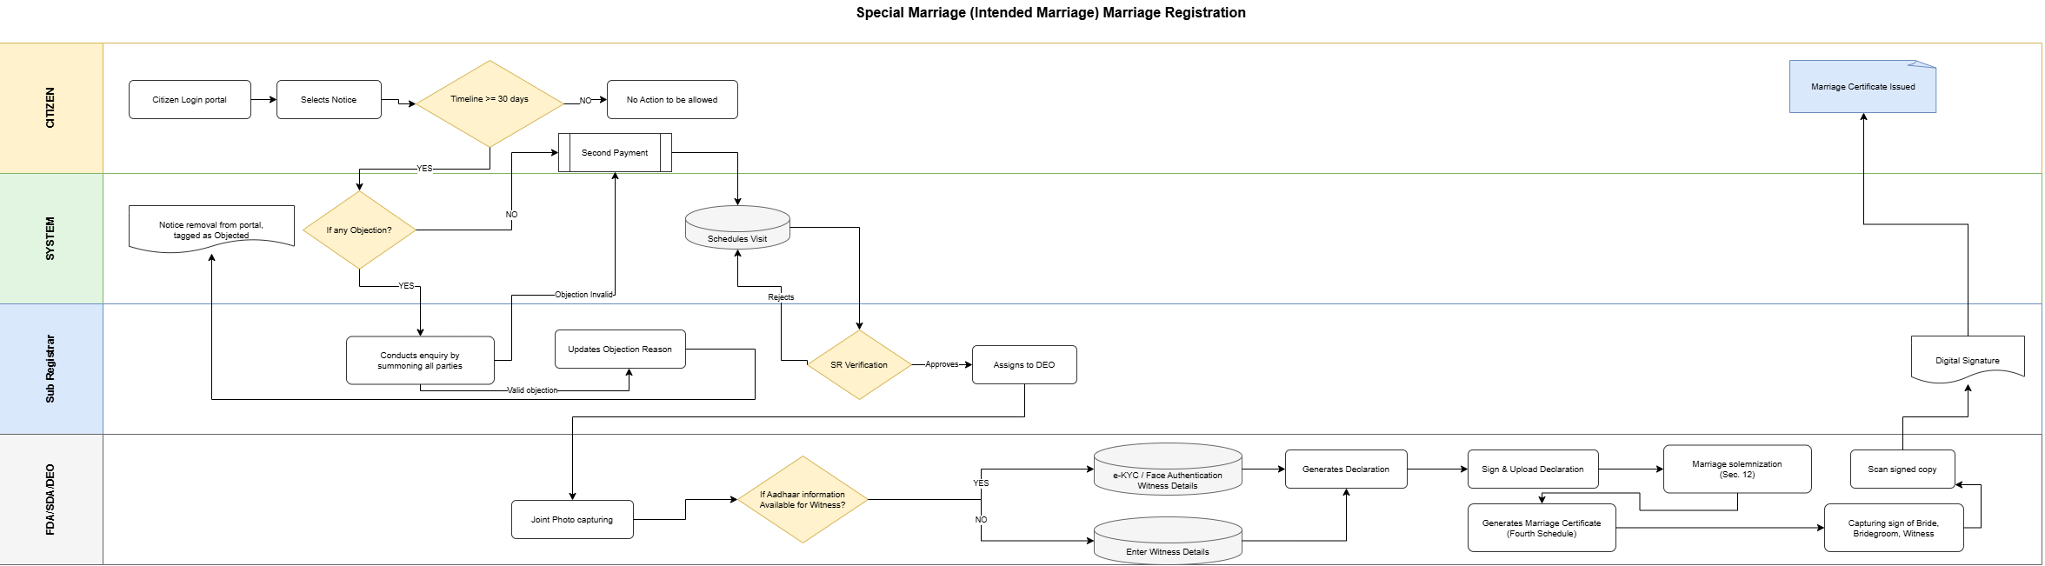

Figure: Special Marriage Other Forms Marriage Registration
Flow (after notice publication — registration / solemnization steps; shared by Intended Marriage and Other Forms):

# | Step | Lane | Notes
1 | Citizen Login portal | Citizen | Continue from published notice
2 | Select Notice | Citizen | Choose approved / published notice
3 | Validate timeline — Intended: ≥ 30 and ≤ 90 days (Sec. 7 / Sec. 14); Other Forms: ≥ 30 days (no ≤ 90 gate) | System | If NO → No Action allowed (path-specific gate)
4 | If any Objection? | System | Branch to SR enquiry when objection exists
4a | Conduct enquiry by summoning all parties | Sub Registrar | Sec. 8–9
4b | Valid objection → update reason; Notice removal from portal (Objected) | Sub Registrar / System | Process stops for solemnization
4c | Objection invalid → continue | Sub Registrar | Proceed to Second Payment
5 | Second Payment | System / Citizen | Registration / solemnization fee
6 | Schedule Visit | System / Citizen | Office visit for solemnization
7 | SR Verification (decision) | Sub Registrar | Approve or Reject
7a | Reject → return to Schedule Visit | Sub Registrar → System | Reschedule / correct
8 | Assigns to DEO | Sub Registrar | Certificate / declaration production
9 | Joint Photo capturing | FDA / SDA / DEO
10 | If Aadhaar available for Witness → e-KYC / Face Authentication Witness Details; else Enter Witness Details | FDA / SDA / DEO | Three witnesses (Sec. 11) — after joint photo
11 | Generates Declaration | FDA / SDA / DEO | Third Schedule declarations
12 | Sign & Upload Declaration | FDA / SDA / DEO | Signed declaration uploaded
13 | Marriage solemnization (Intended, Sec. 12) / registration (Other Forms, Chapter III Sec. 15–16) | Sub Registrar | Chapter II solemnization vs Chapter III registration
14 | Generate Marriage Certificate — Fourth Schedule (Intended) / Fifth Schedule (Other Forms) | FDA / SDA / DEO | Fourth Schedule Sec. 13 / Fifth Schedule Sec. 16
15 | Capture signs of Bride, Bridegroom, Witness | FDA / SDA / DEO
16 | Scan signed copy | FDA / SDA / DEO
17 | Digital Signature (DSC) | Sub Registrar
18 | Marriage Certificate Issued | Citizen / System | Download from portal

Key characteristics: notice selection with path-specific timeline gate (Intended ≥30 and ≤90; Other Forms ≥30); objection enquiry branch (valid objection removes notice); Second Payment; schedule visit; SR verification; DEO joint photo then witness capture (e-KYC / Face Authentication or manual), declaration generate/sign/upload, solemnization or Chapter III registration, certificate & signatures; SR DSC; certificate issuance (Fourth or Fifth Schedule).

Application Status Model
Application statuses for Special Marriage Marriage Registration (Intended Marriage / Other Forms):
Status | Description | Actor | Next states
Notice valid for registration | Entry point — Intended: notice ≥ 30 and ≤ 90 days with no valid objection; Other Forms: notice ≥ 30 days with no valid objection | Citizen | Second payment completed
Second payment completed | Registration / solemnization fee paid | System | Visit scheduled
Visit scheduled | Solemnization visit (Intended) or registration visit (Other Forms) booked | Citizen | Pending SR verification — visit
Pending SR verification — visit | SR verification before solemnization | SR | Solemnized / Rejected — visit
Rejected — visit | Returned to visit scheduling with reason | SR | Visit scheduled
Solemnized | Marriage solemnized (Chapter II) or conditions satisfied for registration (Chapter III) | SR | Allocated to DEO — certificate
Allocated to DEO — certificate | Joint photo, certificate generation and signature capture | DEO | Signed certificate uploaded
Signed certificate uploaded | Signed certificate uploaded for SR digital signature | DEO | Pending SR digital signature
Pending SR digital signature | Awaiting DSC | SR | Certificate issued
Certificate issued | Marriage certificate downloadable from portal | System | Closed
Closed | No further action | System | —

Parsi Marriage

Channel models
Parsi Marriage registration supports Online and Offline (In Person) channels for registering a marriage already solemnized per Parsi rites. Channel is selected before prerequisites and drives subsequent screens, payment timing and office tasks.
Service Type | Online Activities | Office Activities | Mode
Parsi Marriage Online | Registration, e-KYC / Face Authentication (Bride), upload priest-certified Schedule II certificate, eSign, Payment (post-approval), Tracking | Verification, DSC | Online
Parsi Marriage Offline | Registration, Payment, Appointment Booking, Printout | SR Stage 1, SR→DEO allocation, Certificate upload, SR Stage 2, DSC | Offline

Process Diagram

Common intake steps
Identical in both Parsi Marriage diagrams (Citizens and System lanes):
- START — citizen initiates the service.
- LogOn to Portal — authenticated citizen session.
- Start a new Application.
- Marriage Registration — citizen selects the marriage registration service.
- Select channel: Parsi Marriage Online / Parsi Marriage Offline. Channel is chosen before prerequisites.
- Read and continue with Prerequisite for marriage and complete declaration — single combined acknowledgement screen (solemnization per Parsi rites, the ‘Ashirvad’ ceremony, before a priest and two Parsi witnesses per Sec. 3(b); age eligibility — bridegroom ≥ 21, bride ≥ 18 per Sec. 3(c); parties not within the prohibited degrees at Schedule I; no subsisting marriage per Sec. 4). SR rejection of the application returns here for correction and resubmission.
- Enter / capture Marriage details, Bride details, Bridegroom details, Priest details, Witness details (two) — persisted to the application record; upload the priest-certified Schedule II Certificate of Marriage (Sec. 6). Online channel: e-KYC / Face Authentication on Bride details (see 7.iv.b.B). Offline channel: whether the priest-certified Schedule II certificate / Aadhaar information is available — if yes, e-KYC / Face Authentication on Bride & Bridegroom details; if no, manual data entry (see 7.iv.b.C). This step is the re-entry point for SR rejection loops that return to citizen data entry in both diagrams.

Online
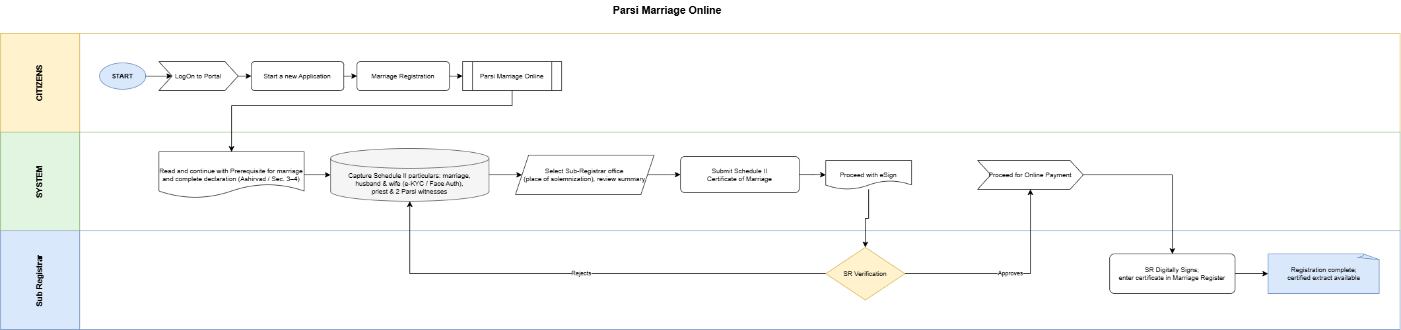

Figure: Parsi Marriage Online process
Flow (continuing from 7.iv.b.A step 7 — Online-specific steps):
# | Step | Lane | Notes
7 | Capture marriage / priest / witness details; e-KYC / Face Authentication on Bride details; upload priest-certified Schedule II certificate | System / Citizen | Per Online diagram: e-KYC / Face Authentication applied on Bride details during capture
8 | Select Sub-Registrar office (jurisdiction = place of solemnization) and review summary of updated information | System / Citizen | Jurisdiction routing per Sec. 6 / Notification HD 6 PIM 67
9 | Submit application referencing the uploaded Schedule II certificate | System / Citizen | Certificate reference captured for SR verification
10 | Proceed with eSign | System / Citizen | Citizen eSign on application
11 | SR Verification (decision) | Sub Registrar | Approve or Reject — verified against the priest-certified Schedule II certificate
11a | Reject → return to Enter Marriage / Bride / Bridegroom / Witness details | Sub Registrar → System | Citizen corrects and resubmits
12 | Proceed for Online Payment | System / Citizen | Payment occurs only after SR approval
13 | SR Digitally signs; register entry made (Sec. 6 / 8) | Sub Registrar | DSC applied; entry made in the marriage register
14 | Marriage certificate (registration extract) issued | Sub Registrar / System | System-generated registration certificate / extract available for download
Key characteristics: channel before combined prerequisite+declaration; marriage is solemnized outside the portal by a Parsi priest per the Ashirvad ceremony — Kaveri registers the already-certified marriage; priest-certified Schedule II certificate uploaded and verified by the SR; e-KYC / Face Authentication on Bride details during capture; SR office selection = place of solemnization; single SR verification; payment only after SR approval; fully digital signature chain; no printout, no appointment, no DEO.

Offline (In Person)
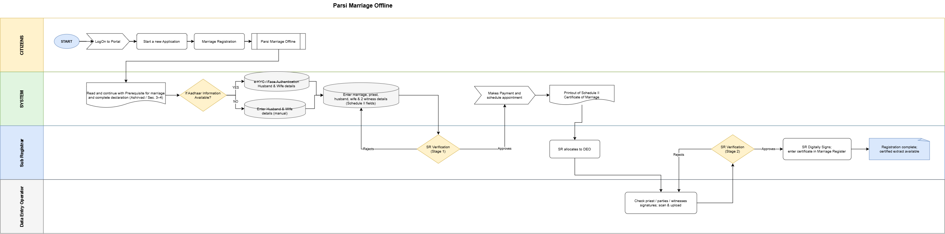

Figure: Parsi Marriage Offline process
Flow (continuing from 7.iv.b.A step 7 — Offline-specific steps):
# | Step | Lane | Notes
7 | Whether priest-certified Schedule II certificate / Aadhaar information is available? If Yes → e-KYC / Face Authentication on Bride & Bridegroom details; if No → Enter Bride & Bridegroom details (manual) | System / Citizen | Per Offline diagram (certificate / Aadhaar YES/NO branch); witness details captured with party particulars
8 | Enter Marriage, Priest & Witness details; upload scanned Schedule II certificate & party proofs | System / Citizen
9 | SR Verification — Stage 1 (decision) on captured application data | Sub Registrar | Approve or Reject
9a | Reject → return to Enter Marriage / Bride / Bridegroom / Priest / Witness details | Sub Registrar → System | Citizen corrects and resubmits
10 | Makes Payment and schedule appointment | System / Citizen | Payment and slot booking in one step, after Stage 1 approval
11 | Printout taken on Application and Schedule II certificate copy | System / Citizen | Citizen prints the application pack for the appointment
12 | SR allocates to DEO | Sub Registrar | Explicit allocation step before DEO upload
13 | Priest, parties and witnesses sign the Schedule II certificate physically; citizen attends the SRO on the appointment date | Citizen (offline activity) | Not a system step; precondition for DEO upload
14 | DEO checks certificate details and signatures, uploads scan on portal | Data Entry Operator | DEO verifies signatures / details are present / complete, scans and uploads
15 | SR Verification — Stage 2 (decision) on the uploaded signed certificate | Sub Registrar | Approve or Reject
15a | Reject → return to DEO check / upload step | Sub Registrar → DEO | Re-check or re-upload; does not go back to citizen data entry
16 | SR Digitally Signs; register entry made (Sec. 6 / 8) | Sub Registrar | DSC applied
17 | Marriage certificate (registration extract) issued | Sub Registrar / System | Registration extract issued
Key characteristics: channel before combined prerequisite+declaration; whether the priest-certified Schedule II certificate / Aadhaar is available — e-KYC / Face Authentication on Bride & Bridegroom or manual data entry (YES/NO branch); SR Verification Stage 1 on captured data before payment; payment + appointment bundled; printout of the application and Schedule II certificate copy; SR allocates to DEO; physical signing at the SRO precedes DEO upload; DEO signature check and upload; SR Verification Stage 2 on the uploaded signed certificate (reject returns to DEO); SR DSC applies the register entry, then the certificate.

Application Status Model
Channel-aware application statuses for Parsi Marriage Online and Offline:
Status | Description | Actor | Next states
Draft | Saved not submitted | Citizen | Channel selected
Channel selected | Online or Offline chosen (before prerequisites) | Citizen | Prerequisite & declaration completed
Prerequisite & declaration completed | Combined prerequisite + declaration acknowledged (Ashirvad ceremony, age, prohibited degrees, no subsisting marriage) | Citizen | Details captured
Details captured | Marriage / bride / bridegroom / priest / witness details and Schedule II certificate saved (Online: e-KYC / Face Authentication on Bride details; Offline: e-KYC / Face Authentication on Bride & Bridegroom when certificate / Aadhaar available, else manual) | Citizen | Office selected (Online) / Pending SR verification Stage 1 (Offline)
Office selected & summary reviewed | SRO office (place of solemnization) chosen, summary confirmed | Citizen | Application submitted
Application submitted | Application referencing the Schedule II certificate submitted | Citizen | eSign pending
eSign pending | Awaiting citizen eSign | Citizen | Pending SR verification
Pending SR verification | Awaiting SR scrutiny against the Schedule II certificate | SR | Approved for payment / Rejected — data
Rejected — data correction | Sent back to citizen data entry | SR | Details captured
Approved for payment | SR approved; fee payable | SR | Payment completed
Payment completed | Fee paid, receipt issued | System | Pending SR digital signature (Online) / Appointment scheduled (Offline)
Appointment scheduled | SRO visit slot booked | Citizen | Forms printed
Forms printed | Application + Schedule II certificate printout taken | Citizen | Allocated to DEO
Allocated to DEO | SR has allocated the application to a DEO | SR | Awaiting signed-certificate upload
Awaiting signed-certificate upload | Physically signed Schedule II certificate pending at SRO | Citizen / DEO | Signed certificate uploaded
Signed certificate uploaded | DEO checked signatures and uploaded | DEO | Pending SR verification — Stage 2
Pending SR verification — Stage 2 | Awaiting SR scrutiny of the uploaded signed certificate | SR | Pending SR digital signature / Rejected — upload
Rejected — upload | Sent back to DEO for re-check / re-upload | SR | Signed certificate uploaded
Pending SR digital signature | Awaiting DSC | SR | Registered
Registered | Register entry made (Sec. 6 / 8) | SR | Certificate issued
Certificate issued | Registration certificate / extract generated / downloadable | System | Closed
Closed | No further action | System | —

Marriage — Null and Void Endorsement (Court Order)
Back-office workflow triggered when a competent court passes an order declaring a registered marriage void (sec 11) or annulling a voidable marriage (Sec. 12, the Sub-Registrar records the court order and flags the existing registration as Null and Void. This workflow is initiated only on presentation of a certified court order copy — not from citizen self-service or automated eligibility checks.

Process steps
Offline (In Person) at the Sub-Registrar office — steps only (no process diagram):
# | Step | Lane | Notes
1 | Sub-Registrar receives certified copy of court order declaring the marriage void or annulled (nullity decree) | Sub Registrar | HMA 1955 Sec. 11–12; physical or scanned copy presented at SRO office
2 | Sub-Registrar searches and opens the registered marriage record in Kaveri | Sub Registrar | By registration number, party name or Form II-A certificate number
3 | Sub-Registrar verifies court order particulars against the register entry (court name, case number, order date, parties) | Sub Registrar | Hard stop if parties or registration number do not match
4 | Sub-Registrar uploads / scans the court order copy | Sub Registrar | Mandatory artefact; retained per records policy (Rule 10)
5 | Sub-Registrar records nullity type as declared in the court order — Void (Sec. 11) or Voidable / annulled (Sec. 12) | Sub Registrar | Selection driven by court order wording
6 | Sub-Registrar flags the marriage registration as Null and Void | Sub Registrar | Endorsement on register entry; supersedes prior Registered / Certificate Issued status
7 | System updates register entry and certificate status | System | Form II-A marked invalid; Hindu Marriages Register shows NULL AND VOID endorsement
8 | System prevents issuance of certified extracts without null/void notation | System | Any subsequent extract shall reflect the endorsement (Rule 8)
9 | Audit trail recorded | System | Officer, timestamp, court order reference, prior and new status

What is new in Kaveri 3.0
This section summarises material enhancements in Kaveri 3.0 compared with the legacy Kaveri 2.0 Marriage Registration module (6). Capability highlights are listed below; 7.vi.a maps each As-Is pain point from 6.1 to the Kaveri 3.0 closure. Cross-references point to To-Be process in this BRD (7.i–7.v) and to functional / non-functional requirements in 8–9 of this document.
# | Capability | What is new in Kaveri 3.0
1 | Dual-channel services | Special Marriage Notice
2 | Identity verification | Face Authentication on Online paths
3 | New service coverage — Parsi Marriage | End-to-end Parsi Marriage registration (Online and Offline) added under the Parsi Marriage and Divorce Act, 1936 and the Parsi Marriages and Divorce (Karnataka) Rules, 1961 — not available in Kaveri 2.0 (see 7.iv)
7 | Null and Void endorsement | SRO back-office workflow to record certified court order and flag registered Hindu marriage Null and Void (HMA 1955 Sec. 11–12)
9 | Data capture and address quality | Structured party/witness capture; MDM-driven address; place of marriage in summary and reports; cross-reference search for registered marriages
10 | Payments and notifications | Integrated fee payment with receipt (Form VI); resilient payment fallback; SMS and e-Mail notifications across application lifecycle
11 | Integrations | Kutumba portal, Civil Registration System, Labor Department
12 | UI/UX experience | Mobile-responsive bilingual UI (English + Kannada); guided step flow with Save/resume; summary review before submit and eSign
13 | Certified copy cross-references | Multiple cross-references on certified copy of registered marriage document (FR-HMA-100)
14 | e-Governance address & certificate language | Address capture per e-Governance standard; citizen selects certificate language with preview before confirm
15 | Age-proof integrations & SR Refusal | e-Janma and Marks Card pull for Birth Certificate / age proof; SR Refusal with reason and order before registration/solemnization; Form II removed for Hindu Marriage

Rectified As-Is pain points
The following As-Is pain points from 6.1 (Kaveri 2.0 workshops, ServiceDesk tickets and department discussions) shall be closed in Kaveri 3.0.
Sr.No | Pain Point (As-Is) | How rectified in Kaveri 3.0
1 | Not mobile-friendly | Mobile-responsive bilingual UI; guided step flow usable on phone browsers
2 | Incorrect address on certificate | Structured party address capture without erroneous sub-district on Form II-A
3 | Complex area/village selection | MDM-driven jurisdiction / area selection with simplified routing
4 | Restrictive document upload rules | Relaxed size/dimension rules with clear validation messages for supporting documents
5 | Missing Save action for Witness 3 | Witness capture supports Save for all three witnesses before submission
6 | Edit does not return to correct step | Edit from in-progress application resumes at the correct channel-aware status step
7 | Documents not visible during scrutiny | SRO scrutiny view shows all uploaded supporting documents with the application
8 | No edit flexibility before payment | Citizen may navigate back and edit captured data until sub-registrar approval for payment
9 | No processing priority order | FIFO / priority handling for officer queues
10 | Password-protected uploads not handled | Clear reject/retry for password-protected documents (FB-MRG-003)
11 | Limited notification channels | Lifecycle notifications via both SMS and e-Mail
12 | No operational dashboard visibility | MIS / dashboard for daily registrations, pendency and officer workload
13 | Wrong DEO allocation and no reassignment | SR allocates to DEO; officers can reassign without Service Desk
14 | Notice workflow state errors | Channel-aware notice / registration status model; post-period actions gated correctly
15 | Blank challan / verify-challan loop | Integrated payment with receipt and resilient payment fallback
16 | Stuck on summary page — cannot go to next step | Summary review then proceed / eSign with explicit next-step navigation
17 | DOB and party details not reflecting | Party particulars (including DOB) persist and display on summary, forms and certificate
18 | Place of marriage missing in summary/report | Place of marriage captured once and shown on summary, forms and MIS
19 | Cross-reference to registered marriage missing | Search / cross-reference to registered marriage records (post-registration)
20 | Signatures missing on digitally signed certificate | Bride, bridegroom and witness signatures rendered on DSC-signed certificate
21 | Notice number and notice date not displaying | Notice number and notice date shown after generation / publication

Functional requirements
Functional requirements are organized by service, aligned with 7 (To-Be). Section 7 is the process authority — channel models, diagrams, step tables and status models. Section 8 states testable functional requirements (FR-HMA-* / FR-SMA-*) and does not restate those process steps. Where a requirement implements a To-Be step, the FR cites the 7 reference. Cross-cutting post-registration, notification and MIS requirements follow the service-specific blocks.

Hindu Marriage

Eligibility and module entry
Req ID | Requirement | Priority
FR-HMA-001 | System shall allow registration only for marriages claimed to be solemnized under HMA 1955 (Section 2 applicability) | Must
FR-HMA-002 | System shall block or warn if marriage date is in future | Must
FR-HMA-003 | System shall enforce minimum age at date of marriage: bridegroom 21, bride 18 (Section 5(iii)) | Must
FR-HMA-004 | System shall capture marital status at time of marriage (unmarried / widower / widow / divorced) per Form I | Must

Jurisdiction and office routing
Req ID | Requirement | Priority
FR-HMA-005 | Applicant shall select basis for jurisdiction: place of marriage | Must
FR-HMA-006 | System shall route application to Sub-Registrar office matching selected jurisdiction (anywhere in district) | Must

Data capture — marriage details
Req ID | Requirement | Priority
FR-HMA-007 | Capture date of marriage | Must
FR-HMA-008 | Capture place of marriage with sufficient particulars to locate (address, district, state) | Must
FR-HMA-009 | Capture description of ceremony / rites (Section 7) | Should

Data capture — bridegroom
Req ID | Requirement | Priority
FR-HMA-010 | System shall capture bridegroom particulars as per Form I (name, parentage, age/DOB, addresses, marital status, signature/eSign, email optional, mobile) | Must
Field (statutory) | Mandatory | Validation / notes | Kaveri 3.0 field name
Salutation | Y
Full name | Y | Shall be imported through e-KYC / Face Authentication | [TBD]
Father's name | Y
Mother's name | Y
Age at marriage | Y | Cross-check DOB, Shall be imported through e-KYC / Face Authentication (if available)
Current address of residence | Y | Shall be imported through e-KYC / Face Authentication; Address capture shall follow the e-Governance / MeitY address data standard (structured house/door no., street/locality, village/town/city, taluk, district, state, PIN / postal code, country) with MDM codes where available
Permanent address of residence | Y | Address capture shall follow the e-Governance / MeitY address data standard (structured house/door no., street/locality, village/town/city, taluk, district, state, PIN / postal code, country) with MDM codes where available
Status (unmarried/widower/divorced) | Y
Email | O | Validated through OTP
Mobile | Y | Validated through OTP
FR-HMA-101 | System shall capture party and witness addresses as per the e-Governance address standard (structured components and PIN/postal code; MDM-driven district/taluk/village or urban locality). Free-text-only address shall not be the sole capture mode | Must | Structured address fields mandatory; certificate and forms render e-Gov standard address without erroneous sub-district

Data capture — bride
Req ID | Requirement | Priority
FR-HMA-011 | System shall capture bride particulars as per Form I (name, parentage, age/DOB, addresses, marital status, signature/eSign, email optional, mobile); Online channel applies e-KYC / Face Authentication / Face Authentication per FR-HMA-058 | Must
Field (statutory) | Mandatory | Validation / notes | Kaveri 3.0 field name
Salutation | Y
Full name | Y | Shall be imported through e-KYC / Face Authentication | [TBD]
Father’s name | Y
Mother’s name | Y
Age at marriage | Y | Cross-check DOB, Shall be imported through e-KYC / Face Authentication (if available)
Current address of residence | Y | Shall be imported through e-KYC / Face Authentication; Address capture shall follow the e-Governance / MeitY address data standard (structured house/door no., street/locality, village/town/city, taluk, district, state, PIN / postal code, country) with MDM codes where available
Permanent address of residence | Y | Address capture shall follow the e-Governance / MeitY address data standard (structured house/door no., street/locality, village/town/city, taluk, district, state, PIN / postal code, country) with MDM codes where available
Status (unmarried/widower/divorced) | Y
Signature + date | Y | e-sign
Email | O | Validated through OTP
Mobile | Y | Validated through OTP

Data capture — witnesses
Req ID | Requirement | Priority | Acceptance criteria
FR-HMA-012 | System shall capture exactly three witnesses | Must
FR-HMA-013 | Each witness: full name, blood relation if any, age, current and residence, address, signature + date | Must
FR-HMA-014 | Witness identity verification via [Aadhaar e-KYC / Face Authentication / manual] | Must

Field (statutory) | Mandatory | Validation / notes | Kaveri 3.0 field name
Full name | Y | Shall be imported through e-KYC / Face Authentication | [TBD]
Age | Y | Cross-check DOB, Shall be imported through e-KYC / Face Authentication (if available)
Current address of residence | Y | Shall be imported through e-KYC / Face Authentication; Address capture shall follow the e-Governance / MeitY address data standard (structured house/door no., street/locality, village/town/city, taluk, district, state, PIN / postal code, country) with MDM codes where available
Permanent address of residence | Y | Address capture shall follow the e-Governance / MeitY address data standard (structured house/door no., street/locality, village/town/city, taluk, district, state, PIN / postal code, country) with MDM codes where available
Signature + date | Y | e-sign
Mobile | Y | Validated through OTP

Form I — memorandum generation and completeness
Req ID | Requirement | Priority
FR-HMA-015 | Generate Form I (Memorandum of Marriage) in duplicate per Rule 4(1) for the selected office | Must
FR-HMA-016 | Ensure Form I includes all statutory particulars (items 1–7) and is e-signed (signed) by the bride, bridegroom and three witnesses | Must
FR-HMA-017 | Populate Form I date and place of marriage from captured marriage details (Form I items 1–2) | Must

Form IA — application and declarations
Req ID | Requirement | Priority
FR-HMA-083 | Generate Form IA addressed to Registrar of Marriage for selected office | Must
FR-HMA-084 | Capture statutory declarations on Form IA: (I) valid marriage registrable under Section 8; (II) Section 5 conditions satisfied; (III) particulars true to best knowledge | Must
FR-HMA-085 | Capture solemnization date in Form IA narrative (align with Form I date of marriage) | Must
FR-HMA-091 | At Form I / Form IA submission (Hindu Marriage Online: immediately before citizen eSign; Hindu Marriage Offline: immediately before SR Verification Stage 1 submission), system shall display statutory highlight panels for HMA Sec. 17 (Punishment of bigamy) and Sec. 18 (Punishment for contravention of certain other conditions for a Hindu marriage) in red (#C00000 or department-approved accessible equivalent), using the wording in 3.5; citizen shall explicitly acknowledge before submission proceeds | Must

Supporting documents and memorandum
Req ID | Requirement | Priority
FR-HMA-018 | Upload joint photo of bride and bridegroom (Form I header) | Must
FR-HMA-019 | Document checklist: [age proof, address proof, divorce decree if applicable], the document checklist is configurable.  Age proof documents – Birth certificate (pull from e-Janma where available), School Certificate / Marks Card, if these are not available then medical certificate from the doctor.  AADHAR cannot be considered for age proof.  Address Proof Documents: Aadhaar Card, (Electricity/Telephone/Water) Bill, Voter ID Card, Gas connection certificate, Rental Agreement, Income Tax Assesment, Employer certificate, Passport, Bank Passbook (national and regional rural banks).  System shall integrate with e-Janma and Marks Card sources to pull Birth Certificate / school marks-card particulars for age / DOB verification when the citizen opts in | Must
FR-HMA-102 | System shall integrate with e-Janma and Marks Card services to retrieve Birth Certificate / marks-card data for age and date-of-birth verification during marriage registration. Citizen may still upload age proof manually where pull fails or is unavailable | Must

Fees and payments
Req ID | Requirement | Priority
FR-HMA-020 | Applicable fee as per the Karnataka fees of schedule | Must
FR-HMA-021 | Issue payment receipt equivalent | Must
FR-HMA-022 | System shall enable the payment step only after SR approval (Online: SR Verification; Offline: SR Verification Stage 1) | Must
FR-HMA-023 | Offline channel: payment and appointment scheduling shall be completed as a single guided step | Must
FR-HMA-024 | System shall not permit certificate generation unless payment is successfully reconciled | Must
FR-HMA-025 | Handle payment failure / timeout with retry without re-triggering SR verification | Must

SRO scrutiny and registration
Req ID | Requirement | Priority | Acceptance criteria
FR-HMA-026 | SRO shall view complete application, documents, payment status | Must
FR-HMA-027 | SRO may require parties to remedy defects | Must | Audit trail
FR-HMA-028 | SRO shall refuse incomplete Form I (memorandum) or Form IA with brief written order communicated to parties | Must
FR-HMA-030 | On completion: issue Form II-A certificate immediately | Must | download
FR-HMA-103 | Before registration of the marriage, the Sub-Registrar shall have the option to Refuse the application with a recorded reason and a brief written / typed order (DSC-signed). Refusal shall be communicated to the parties and shall block certificate issuance until remedied or closed | Must | Refuse action available on SR workbench before register entry / Form II-A; reason + order PDF + notification; audit trail

Channel selection and prerequisite acknowledgement
(Ref: 7.1.2.1 steps 5–6 — both diagrams; channel then combined prerequisite+declaration)
Req ID | Requirement | Priority | Acceptance criteria
FR-HMA-046 | After channel selection, system shall display a combined Prerequisite for marriage and complete declaration screen that the citizen must read and explicitly continue from | Must | Acknowledgement timestamped and audited
FR-HMA-047 | System shall present a channel choice (Hindu Marriage Online or Hindu Marriage Offline) immediately after Marriage Registration service selection and before the prerequisite+declaration screen | Must | Selection stored on the application
FR-HMA-048 | System shall explain the practical difference at the point of choice (eSign vs printout + physical signature + SRO appointment) | Must | Bilingual EN/KN
FR-HMA-049 | Selected channel shall drive all subsequent screens | Must
FR-HMA-050 | Both channels shall reuse the same combined prerequisite+declaration and core data-capture screens (7.1.2.1 steps 6–7), with Online applying e-KYC / Face Authentication on Bride/groom details | Must | Single source of validation logic

Online channel — office, Form I & Form IA, eSign
(Ref: 7.1.2.2)
Req ID | Requirement | Priority | Acceptance criteria
FR-HMA-051 | Citizen shall select the Sub-Registrar office and view a summary of all updated information before submission | Must | Summary shows marriage, bride, bridegroom, witness data
FR-HMA-052 | Citizen shall be able to return and edit any required sections only | Must | No data loss
FR-HMA-053 | System shall generate and allow submission of Form I (Memorandum) from captured data | Must | Form I generated for the selected office; filed with Form IA (FR-HMA-086)
FR-HMA-054 | System shall support eSign on Form I by the required signatories (parties and three witnesses) | Must | (parties, witnesses)
FR-HMA-055 | eSign artefacts (signed PDF, signature metadata, timestamp) shall be stored and rendered immutable | Must | Retrievable for audit and SR review
FR-HMA-056 | System shall handle eSign failure / abandonment with resumable retry | Must | Status remains eSign pending
FR-HMA-057 | Application shall move to SR verification only after eSign is complete | Must | Mandatory
FR-HMA-058 | Online channel: system shall perform e-KYC / Face Authentication on Bride details during application capture (per Online process diagram) | Must | e-KYC / Face Authentication success recorded before summary/office selection; failure blocks progress with clear message
FR-HMA-086 | System shall generate and allow submission of Form IA with the selected declaration (accompanies Form I per Rule 4(2)) | Must | Form IA addressed to the selected office
FR-HMA-087 | System shall support eSign on Form IA / declarations by the required party signatories | Must | Signed Form IA stored with Form I eSign artefacts
FR-HMA-089 | During Aadhaar e-KYC / Face Authentication for bride and bridegroom, the OTP SMS (or equivalent one-time code message) sent to the party shall state the reason why the OTP is requested (e.g. identity verification for Hindu Marriage registration application) | Must | OTP / SMS template reviewed by department; reason text visible before code entry; applies to Hindu Marriage Online and Offline e-KYC paths

Offline channel — printout (Form I, Form IA, Form II-A), DEO upload
(Ref: 7.1.2.3 including SR allocates to DEO)
Req ID | Requirement | Priority | Acceptance criteria
FR-HMA-059 | On Stage 1 approval, citizen shall pay the fee and schedule an appointment at the selected SRO (before printout and SR→DEO allocation) | Must | Slot, date, time, office recorded
FR-HMA-060 | System shall provide appointment slot availability, confirmation, and reschedule / cancel rules | Should | Rules
FR-HMA-061 | System shall generate a printout of Form I, Form IA and Form II-A with exact statutory wordings (Form II blank endorsement is not required) | Must | Legal sign-off on templates; Form II not in printout pack; Kannada rendering correct
FR-HMA-062 | Printout shall carry application reference, appointment details and a machine-readable identifier ( QR) for retrieval at the counter | Should | Enables DEO lookup
FR-HMA-063 | DEO shall retrieve the application, check that the printed forms are signed (parties and three witnesses) and upload the scanned forms to the portal | Must | Checklist-driven; per-form confirmation
FR-HMA-064 | DEO shall record a signature-completeness checklist outcome, not merely attach a file | Must | Each required signature ticked
FR-HMA-065 | System shall validate uploads (file type, size, page count) | Must | Reject malformed uploads
FR-HMA-066 | DEO shall be able to replace / re-upload documents when SR rejects at Stage 2 | Must | Version history retained
FR-HMA-067 | All DEO actions shall be attributed to the individual operator and audited | Must
FR-HMA-068 | DEO access shall be restricted to applications of their own SRO office | Must | Jurisdiction-scoped RBAC
FR-HMA-069 | After printout, SR shall explicitly allocate the application to a DEO before the DEO can check signatures and upload (per Offline diagram) | Must | Unallocated applications do not appear in DEO upload queue; allocation audited
FR-HMA-088 | Sub-Registrar shall be able to reassign, recall or override a DEO allocation from the SRO workbench without IT Helpdesk intervention | Must | Reassign / recall audited (actor, from-DEO, to-DEO, timestamp); unblocks As-Is pain point 13; RS-MRG-003
FR-HMA-090 | Offline channel: system shall ask whether Aadhaar information is available for bride and bridegroom; if yes, perform e-KYC / Face Authentication; if no, allow manual capture of bride and bridegroom particulars (per Offline diagram 7.1.2.3) | Must | Aadhaar YES/NO decision node before SR Verification Stage 1; same validation rules as manual path; failure fallback per RS-MRG-002

SR verification
(Ref: 7.1.2.2 / 7.1.2.3)
Req ID | Requirement | Priority | Acceptance criteria
FR-HMA-070 | Online: SR shall verify the eSigned application in a single verification stage | Must | Approve / Reject with reason
FR-HMA-071 | Offline Stage 1: SR shall verify captured application data before payment and appointment | Must | Approve / Reject with reason
FR-HMA-072 | Offline Stage 2: SR shall verify the uploaded physically signed Form I | Must | Approve / Reject with reason
FR-HMA-073 | Rejection at Online SR verification and at Offline Stage 1 shall return the application to the citizen data-entry step | Must | Editable sections, reason visible to citizen
FR-HMA-074 | Rejection at Offline Stage 2 shall return the application to the DEO upload step, not to citizen data entry | Must | Citizen data remains locked
FR-HMA-075 | Every verification decision shall record actor, timestamp, stage, decision and reason code + reason text | Must | Immutable audit
FR-HMA-076 | Rejection shall be issued as a brief written/typed order (DSC signed) communicated to the parties | Must | PDF + notification
FR-HMA-077 | SR queue shall clearly distinguish Online, Offline Stage 1 and Offline Stage 2 work items | Must | Filter + count by stage
FR-HMA-104 | At Online verification and Offline Stage 1 / Stage 2, SR may select Refusal (in addition to Approve / Reject-for-correction). Refusal requires reason code, narrative reason and generates a refusal order before any registration or certificate step | Must | Refusal distinct from return-for-correction; order issued; registration / solemnization blocked

Digital signature, register entry and certificate issuance (Form II-A)
(Ref: 7.1.2.2 / 7.1.2.3)
Req ID | Requirement | Priority | Acceptance criteria
FR-HMA-078 | SR shall digitally sign using a valid DSC before the certificate is issued, in both channels | Must | Signature verifiable on the PDF
FR-HMA-079 | System shall block certificate generation if DSC is unavailable / expired, with a clear message | Must | No unsigned certificate leaves the system
FR-HMA-080 | On SR digital signature: assign serial no., page, volume; update the Hindu Marriages Register electronically; then issue Form II-A (certificate). Separate Form II endorsement artefact is not required | Must | Register entry populated with date received, serial/page/volume and Registrar signature; Form II-A issued — both channels; no Form II
FR-HMA-081 | Certificate shall be issued and made available per channel: Online — portal download; Offline — counter hand-over and download | Must | Delivery mode recorded
FR-HMA-082 | Certificate shall carry integrity features (QR) | Must | Verifiable

Null and Void Endorsement (Court Order)
(Ref: 7.4)
Req ID | Requirement | Priority | Acceptance criteria
FR-HMA-094 | System shall provide an SRO-only back-office function to initiate Null and Void endorsement on a registered Hindu marriage upon presentation of a certified court order (HMA 1955 Sec. 11–12); function shall not be available via citizen self-service | Must | SRO role only; 7.4 step 1
FR-HMA-095 | System shall allow Sub-Registrar to search registered Hindu marriage records by registration number, party name or Form II-A certificate number and verify court order particulars (court name, case number, order date, parties) against the register entry before endorsement | Must | Hard stop on mismatch; 7.4 steps 2–3
FR-HMA-096 | System shall require mandatory upload/scan of certified court order copy before Null and Void endorsement is saved; artefact retained per records policy (Rule 10) | Must | Endorsement blocked without court order artefact; 7.4 step 4
FR-HMA-097 | System shall allow Sub-Registrar to record nullity type as declared in court order — Void (Sec. 11) or Voidable / annulled (Sec. 12) — and flag the marriage registration as Null and Void | Must | Nullity type captured; 7.4 steps 5–6
FR-HMA-098 | On confirmation, system shall update register entry and certificate status: Form II-A marked invalid; Hindu Marriages Register shows NULL AND VOID endorsement; prior Registered / Certificate Issued status superseded | Must | Register and certificate reflect endorsement; 7.4 step 7
FR-HMA-099 | System shall prevent issuance of certified extracts for null/void-endorsed records unless the extract carries the null/void notation; audit trail shall record officer, timestamp, court order reference and prior/new status (Rule 8) | Must | Extracts show notation; audit log retained; 7.4 steps 8–9

Special Marriage (Intended Marriage/Other Forms) Notice Generation

1.2.1 Eligibility and module entry
(Ref: 7.2–7.3 intake; SMA 1954 Sec. 4 and Sec. 15)
Req ID | Requirement | Priority | Acceptance criteria
FR-SMA-001 | System shall route Special Marriage notice via Whether Marriage already taken place or not? after Marriage Registration: No → Special Marriage (Intended Marriage) Notice; Yes → Special Marriage Other Forms Notice (with Enter Marriage Details before Prerequisite). Each path shall support an Online or Offline notice channel | Must | Decision node and path labels match 7.2.2.1 / Online & Offline notice diagrams; four channel×path combinations map to 7.2–7.3
FR-SMA-002 | System shall enforce Sec. 4 conditions for Intended Marriage: neither party has a spouse living; capacity to give valid consent; bridegroom ≥ 21 and bride ≥ 18 years; parties not within degrees of prohibited relationship | Must | Hard stop with statutory reason displayed
FR-SMA-003 | System shall enforce Sec. 15 conditions for Other Forms: ceremony already performed and parties living together as husband and wife since; neither party has more than one spouse living; both parties ≥ 21 years at notice filing date; not within prohibited degrees; residence in the district ≥ 30 days before the date of notice application | Must | Hard stop; conditions captured as declarations
FR-SMA-004 | After path and channel selection, system shall display a combined prerequisite and declaration screen specific to the selected Special Marriage path before data capture | Must | Acknowledgement timestamped and audited
FR-SMA-005 | Selected notice channel (Online / Offline) shall drive all subsequent screens, publication mode and office tasks | Must | Channel stored on the application; single channel per notice
FR-SMA-006 | System shall validate degrees of prohibited relationship against the First Schedule, allowing the custom/usage exception for Other Forms marriages celebrated before commencement of the Act | Should | Exception requires recorded justification
FR-SMA-072 | System shall integrate with e-Janma and Marks Card to pull Birth Certificate / marks-card data for Special Marriage age / DOB verification (Intended Marriage and Other Forms), with manual upload fallback | Must | Source recorded; aligns with circular koE/65/mnmu/2021 age-proof list (Aadhaar not age proof)

Data capture — marriage details
(Ref: 7.2.2.1 common intake; SMA 1954 Sec. 5, Second Schedule; Sec. 15–16 for Other Forms)
Req ID | Requirement | Priority | Acceptance criteria
FR-SMA-007 | System shall capture notice particulars for both parties as per the Second Schedule: name, condition (unmarried / widow / widower / divorcee), occupation, age, dwelling place, permanent dwelling place if different, and length of residence | Must | All Second Schedule fields present on generated notice
FR-SMA-008 | System shall route the notice to the Marriage Officer of the district in which at least one party has resided for ≥ 30 days immediately preceding the notice date, validated against the address proof | Must | Jurisdiction derived and shown before submission
FR-SMA-009 | Online channel: system shall perform e-KYC / Face Authentication on bride and bridegroom details (mandatory; per Online notice diagram 7.2.2.2). Offline channel: e-KYC / Face Authentication on bride and bridegroom where Aadhaar information is available (per Offline notice diagram 7.2.2.3) | Must | Online: no manual bride/bridegroom capture path at notice generation; Offline: e-KYC when Aadhaar available; failure fallback per RS-MRG-002
FR-SMA-010 | Offline channel only: where Aadhaar information is unavailable, system shall allow manual capture of bride and bridegroom details with mandatory documentary proof (per Offline notice diagram 7.2.2.3). Not applicable to Online notice channel | Must | Manual path flagged for SR scrutiny; Online notice channel has no manual bride/bridegroom capture alternative
FR-SMA-011 | System shall accept upload of identity proof, photograph, age proof and address proof for bridegroom and bride | Must | Submission blocked until all mandatory documents uploaded
FR-SMA-012 | System shall present a review summary of captured particulars before document upload and submission | Must | Citizen can return and edit any section from summary
FR-SMA-013 | Online channel: after System notice generation, both parties shall eSign the generated notice; the system shall then display the notice on the portal (publication) | Must | eSign artefacts stored immutably with timestamp; eSign occurs after Notice Generated and before portal publication (7.2.2.2 diagram)
FR-SMA-061 | Special Marriage Other Forms notice only: immediately after Other Forms path selection and before Prerequisite, system shall capture marriage details — date of ceremony, place of ceremony (with sufficient particulars to locate), and form / rites of the already celebrated marriage. These fields shall not be required for Intended Marriage notice | Must | Other Forms: marriage-details step shown before Prerequisite; blocked until complete; Intended Marriage: marriage-details section hidden / not mandatory (7.2.2.1 steps 5–6)
FR-SMA-066 | During Aadhaar e-KYC / Face Authentication for bride and bridegroom in Special Marriage notice generation, the OTP SMS (or equivalent one-time code message) sent to the party shall state the reason why the OTP is requested (e.g. identity verification for Special Marriage notice application) | Must | OTP / SMS template reviewed by department; reason text visible before code entry; applies where e-KYC / Face Authentication is performed in Special Marriage notice generation (Online mandatory; Offline when Aadhaar available)
Marriage details (date of ceremony, place of ceremony, and form / rites of the already celebrated marriage) shall be captured only for Special Marriage Other Forms notice generation — immediately after the Other Forms path is selected (Whether Marriage already taken place or not? = Yes) and before Prerequisite (FR-SMA-061; 7.2.2.1).
They are not required — and must not be presented as mandatory fields — for Special Marriage (Intended Marriage) notice. Intended Marriage notice captures bride and bridegroom Second Schedule particulars only (FR-SMA-007–013). Other Forms notice captures those party particulars plus marriage details (FR-SMA-061). Ceremony declaration at registration remains under FR-SMA-043 (1.3.4).

Data capture — party particulars
Bridegroom and bride share the same Second Schedule party-particulars schema. The field catalogue below is common to both parties. Age and condition validations differ by party and path as noted. Online notice channel: mandatory e-KYC / Face Authentication on bride and bridegroom (FR-SMA-009; 7.2.2.2). Offline notice channel: e-KYC when Aadhaar is available, otherwise manual capture (FR-SMA-009 / FR-SMA-010; 7.2.2.3). Witnesses are not captured at notice generation — three witnesses are captured at registration (FR-SMA-034).
Req ID | Requirement | Priority
FR-SMA-062 | System shall capture bridegroom particulars for Special Marriage notice as per the Second Schedule (name, condition, occupation, age, dwelling place, permanent dwelling place if different, length of residence, signature/eSign, email optional, mobile); Online channel applies e-KYC / Face Authentication where Aadhaar is available (FR-SMA-009) | Must
FR-SMA-063 | System shall capture bride particulars for Special Marriage notice as per the Second Schedule (name, condition, occupation, age, dwelling place, permanent dwelling place if different, length of residence, signature/eSign, email optional, mobile); Online channel applies e-KYC / Face Authentication where Aadhaar is available (FR-SMA-009) | Must
Field (statutory) | Mandatory | Validation / notes | Kaveri 3.0 field name
Salutation | Y
Full name | Y | Shall be imported through e-KYC / Face Authentication (Online, where Aadhaar available) | [TBD]
Father's name | Y
Mother's name | Y
Condition (unmarried / widow / widower / divorcee) | Y | Second Schedule — marital condition
Occupation | Y | Second Schedule
Age | Y | Cross-check DOB; imported through e-KYC / Face Authentication when available. Intended Marriage: bridegroom ≥ 21, bride ≥ 18 (Sec. 4(c)). Other Forms: both parties ≥ 21 (Sec. 15(d))
Current Address | Y | Shall be imported through e-KYC / Face Authentication; used for Sec. 5 jurisdiction
Permanent Address | Y | Required if different from dwelling place; else record same-as-current
Length of residence | Y | Second Schedule / Sec. 15; validate ≥ 30 days before the date of notice application for at least one party (Intended: Sec. 5; Other Forms: Sec. 15)
Email | O | Validated through OTP
Mobile | Y | Validated through OTP
FR-SMA-070 | System shall capture Special Marriage party and witness addresses as per the e-Governance address standard (structured components and PIN/postal code; MDM-driven jurisdiction codes) | Must | Structured address on notice, declarations and certificate

Declaration (The Third Schedule)
This form is required to be e-Signed/signed after 30 days, at the time of solemnization of the marriage

Notice of Intended Marriage (The Second Schedule)
Online: this form (the generated notice) is required to be e-Signed after System notice generation and before portal publication (FR-SMA-013; 7.2.2.2). Offline: physical sign / scan / upload is performed by FDA/SDA/DEO after SR generates the notice (7.2.2.3).
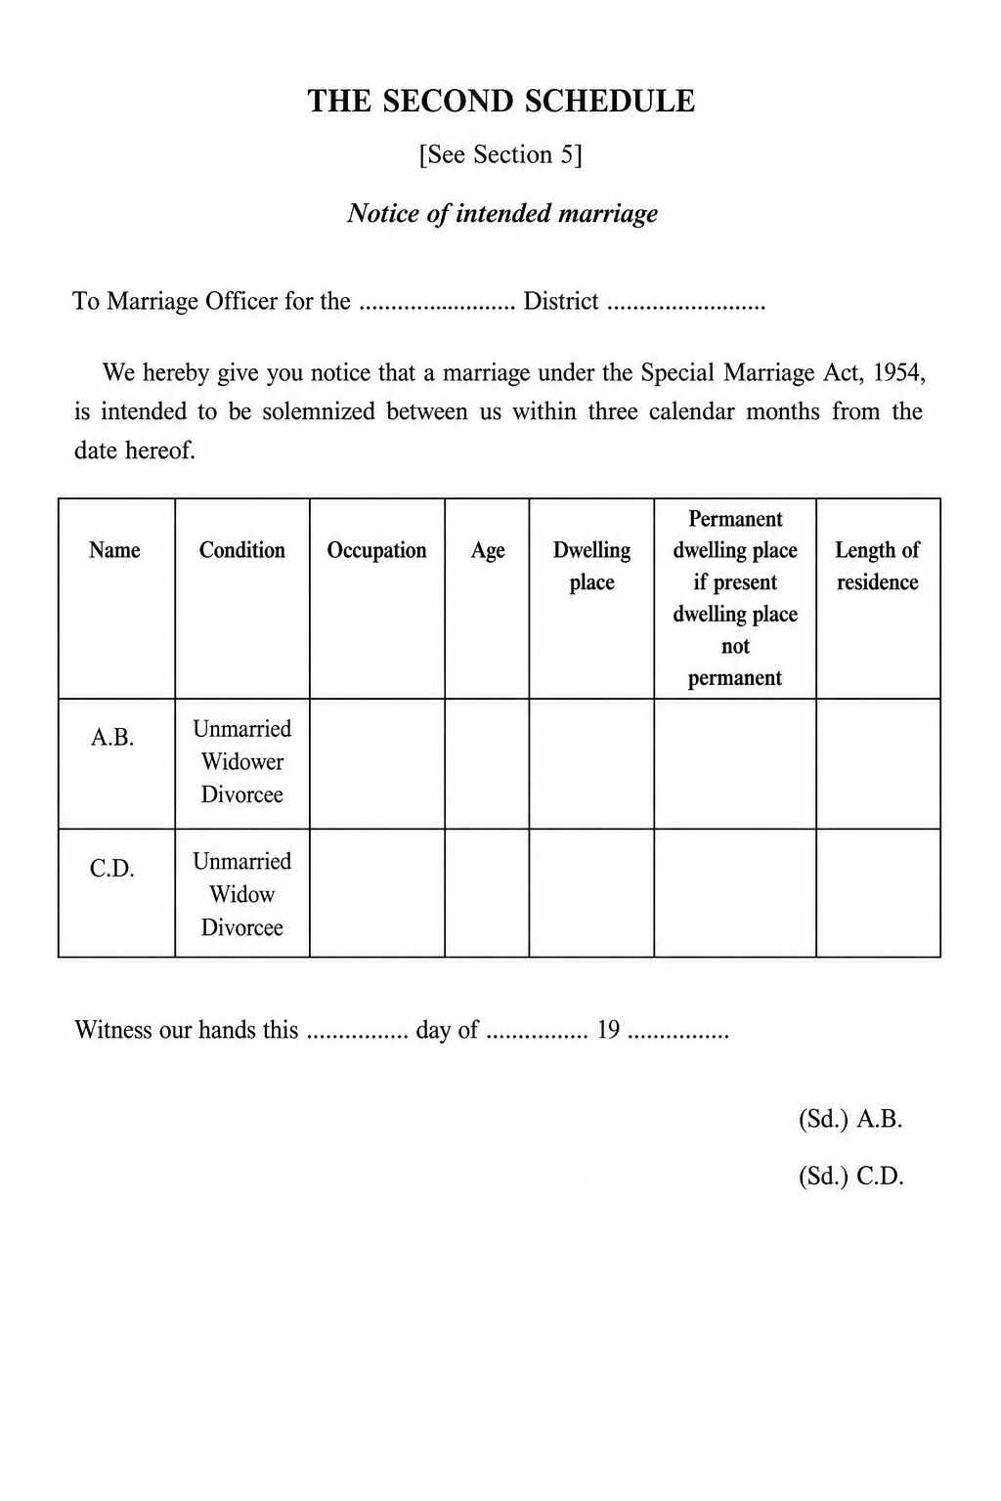

Fees and payments
(Ref: 7.2 / 7.3 first and second payment; Special Marriage (Karnataka) Rules, 1961). Second payment is collected at registration (FR-SMA-033 / FR-SMA-050). Additional fee applies for solemnization outside the Marriage Officer’s office (FR-SMA-051).
Req ID | Requirement | Priority | Acceptance criteria
FR-SMA-049 | System shall collect the first payment (notice fee) after SR verification approval, as per the Special Marriage (Karnataka) Rules fee schedule | Must | No payment before SR approval
FR-SMA-050 | System shall collect the second payment (registration / solemnization fee) before the visit is scheduled | Must | Scheduling blocked until payment success
FR-SMA-052 | System shall generate a receipt with challan / transaction reference and handle payment failure, retry and refund | Must | Failed payments do not advance the application
FR-SMA-053 | Special Marriage fee heads shall be configurable in the fee master without code change | Must | Effective-dated fee versions retained

Notice generation, Marriage Notice Book and publication
(Ref: 7.2.2.2 / 7.2.2.3; SMA 1954 Sec. 5–6)
Req ID | Requirement | Priority | Acceptance criteria
FR-SMA-014 | Marriage Officer (Sub-Registrar) shall generate the statutory Notice of Intended Marriage in the Second Schedule format from the verified application | Must | Notice carries unique notice number and generation date
FR-SMA-015 | System shall enter a true copy of every notice in the Marriage Notice Book with running serial number and date of notice | Must | Sec. 6(1) — entry created automatically on generation
FR-SMA-016 | Marriage Notice Book shall be available for inspection without fee during office hours | Should | Read-only search by notice number, name and date
FR-SMA-017 | Online channel: system shall publish the generated notice on the portal and record the publication date and time | Must | Publication timestamp drives the countdown
FR-SMA-018 | Offline channel: SR shall assign an FDA / SDA / DEO who captures individual photographs of bride and bridegroom, downloads, prints, signs, scans and uploads the notice, and records pasting on the designated notice board | Must | Notice-board pasting recorded with date, office and officer ID
FR-SMA-019 | System shall start a 30-day countdown from the publication date and display days remaining to citizen and office users | Must | Countdown visible on application and notice record
FR-SMA-020 | Where a party is not permanently residing within the district of the notice, system shall transmit a copy of the notice to the Marriage Officer of the district of permanent residence for publication | Must | Sec. 6(3) — transmission logged and acknowledged
FR-SMA-021 | System shall issue an acknowledgement to the citizen with notice number, publication date and registration validity window | Should | Downloadable acknowledgement; SMS / email sent

Notice validity, timeline gate and fresh notice
(Ref: 7.3 timeline decision; SMA 1954 Sec. 14)
Req ID | Requirement | Priority | Acceptance criteria
FR-SMA-029 | Citizen shall initiate marriage registration by selecting a published notice; system shall validate timeline — Intended Marriage: ≥ 30 and ≤ 90 days from publication; Other Forms: ≥ 30 days from publication | Must | Per 7.3 timeline decision (Intended ≤90; Other Forms ≥30 only)
FR-SMA-030 | Where the notice is outside the validity window, system shall allow no further action and display the statutory reason | Must | Notice tagged Expired after the window
FR-SMA-031 | Where the marriage is not solemnized within three months of the notice date, system shall require a fresh notice before the marriage may be solemnized | Must | Sec. 14 — new notice restarts publication and countdown
FR-SMA-032 | System shall alert parties before expiry of the notice validity window | Should | Reminder configurable (e.g. day 75 and day 85)

Special Marriage (Intended Marriage/Other Forms) Marriage Registration

Data capture — witnesses
Req ID | Requirement | Priority | Acceptance criteria
FR-SMA-034 | At the Sub-Registrar office after joint photo capture, system shall capture exactly three witnesses via e-KYC / Face Authentication when Aadhaar is available, otherwise by manual entry | Must | Three witnesses mandatory before declaration / solemnization (not before visit scheduling)
FR-SMA-064 | Each witness: full name, age, current and permanent address of residence, signature + date, mobile | Must | All mandatory witness fields complete for Witness 1–3
FR-SMA-065 | Witness identity verification via Aadhaar e-KYC / Face Authentication / manual documentary proof (If aadhaar available else enter witness details) | Must | Verification method recorded per witness
Field (statutory) | Mandatory | Validation / notes | Kaveri 3.0 field name
Salutation | Y
Full name | Y | Shall be imported through e-KYC / Face Authentication | [TBD]
Age | Y | Cross-check DOB, Shall be imported through e-KYC / Face Authentication (if available)
Current address of residence | Y | Shall be imported through e-KYC / Face Authentication; Address capture shall follow the e-Governance / MeitY address data standard (structured house/door no., street/locality, village/town/city, taluk, district, state, PIN / postal code, country) with MDM codes where available
Permanent address of residence | Y | Address capture shall follow the e-Governance / MeitY address data standard (structured house/door no., street/locality, village/town/city, taluk, district, state, PIN / postal code, country) with MDM codes where available
Mobile | Y

Objection management and enquiry
(Ref: 7.3 objection branch; SMA 1954 Sec. 7–9)
Req ID | Requirement | Priority | Acceptance criteria
FR-SMA-022 | System shall allow any person to file an objection before expiry of 30 days from notice publication, on the ground that the marriage would contravene a condition in Sec. 4 | Must | Objection window closes automatically after day 30
FR-SMA-023 | System shall record the nature of the objection in writing in the Marriage Notice Book, and capture that it was read over and explained to and signed by the objector | Must | Sec. 7(3) — signed record attached to the notice
FR-SMA-024 | System shall block solemnization and registration while an objection is pending decision | Must | Hard gate on the registration flow
FR-SMA-025 | System shall provide an SR enquiry workflow to summon parties, record evidence and decide the objection within 30 days of the date of objection | Must | Sec. 8(1) — breach of 30 days raises an escalation alert
FR-SMA-026 | Where the objection is upheld, system shall record the objection reason, tag the notice as Objected and remove it from portal display | Must | Notice no longer selectable for registration
FR-SMA-027 | Where the objection is found invalid, system shall resume the registration flow at the second payment step | Must | Decision and reason recorded against the notice

Solemnization, declarations and certificate
(Ref: 7.3.2.2; SMA 1954 Sec. 11–13, Third and Fourth Schedules). Witness capture is specified once in Data capture — witnesses (FR-SMA-034, FR-SMA-064–065) and is not repeated here.
Req ID | Requirement | Priority | Acceptance criteria
FR-SMA-033 | System shall collect the second payment (registration / solemnization fee) after the objection check is cleared and before visit scheduling | Must | Receipt generated; prohibited-relationship acknowledgement gate (FR-SMA-067) before scheduling; payment gate on scheduling
FR-SMA-035 | System shall schedule the solemnization visit with the Sub-Registrar and notify all parties | Must | Slot, date, time and office recorded; scheduling blocked until FR-SMA-067 acknowledged
FR-SMA-036 | SR shall verify the application before solemnization; rejection shall return the application to the visit scheduling step with a recorded reason; SR may also Refuse with reason and order (FR-SMA-073) before solemnization / registration | Must | Approve / Reject with reason; no return to notice stage
FR-SMA-037 | DEO shall generate the declarations of the parties and the three witnesses in the Third Schedule form; parties/witnesses shall sign and the signed declaration shall be uploaded before solemnization / registration | Must | Sec. 11 — generate → sign & upload declaration before solemnization (per registration diagram)
FR-SMA-039 | DEO shall capture the joint photograph; after witness capture and signed declaration upload, generate the Certificate of Marriage in the Fourth Schedule, capture signatures of bride, bridegroom and three witnesses, scan and upload the signed copy | Must | Signed copy required before SR digital signature
FR-SMA-040 | System shall enter the certificate in the Marriage Certificate Book and apply the SR digital signature (DSC) before issue | Must | Sec. 13 — signature verifiable on the PDF
FR-SMA-041 | System shall issue the digitally signed certificate for download by the citizen as conclusive evidence of the marriage | Must | Certificate downloadable from portal; SMS / email sent
FR-SMA-067 | During Special Marriage solemnization (Intended Marriage path), after successful second payment (FR-SMA-033 / FR-SMA-050) and before visit / appointment scheduling (FR-SMA-035), system shall display the degrees of prohibited relationship under the First Schedule to the Special Marriage Act, 1954, together with any party relationship particulars already captured; citizen shall explicitly acknowledge before the appointment booking step is enabled | Must | First Schedule text displayed; party relationship context shown where captured; acknowledgement timestamped; appointment booking disabled until acknowledged; applies to Intended Marriage solemnization (Online and Offline)
FR-SMA-071 | Citizen shall select the Special Marriage certificate language (English / Kannada / bilingual as configured). System shall generate a preview before confirming issuance / download (Fourth or Fifth Schedule) | Must | Preview in selected language; confirm gate before issue
FR-SMA-073 | Before solemnization (Intended Marriage) or registration (Other Forms), the Sub-Registrar / Marriage Officer shall have the option to Refuse with a recorded reason and a brief written / typed order (DSC-signed). Refusal shall be communicated to the parties and shall block solemnization / certificate issuance | Must | Refuse available on SR workbench before Sec. 12 solemnization / Sec. 15–16 registration; reason + order + notification

Special Marriage Other Forms — application and registration
(Ref: 7.3; SMA 1954 Chapter III, Sec. 15–18, Fifth Schedule)
Req ID | Requirement | Priority | Acceptance criteria
FR-SMA-042 | System shall accept an application for registration of a marriage celebrated in other forms, signed by both parties to the marriage | Must | Sec. 16 — both signatures / eSign mandatory
FR-SMA-043 | System shall capture the ceremony particulars and the declaration that the parties have been living together as husband and wife since the ceremony | Must | Declaration recorded with date of ceremony
FR-SMA-044 | System shall give public notice of the application in the prescribed manner (portal and / or notice board per selected channel) and allow a period of 30 days for objections | Must | Publication and countdown recorded as in 1.2.7
FR-SMA-045 | SR shall hear any objection received within the 30-day period before deciding the application | Must | Objection workflow of 1.3.2 applies
FR-SMA-046 | On being satisfied that all Sec. 15 conditions are fulfilled, system shall enter the certificate of marriage in the Marriage Certificate Book in the Fifth Schedule format, signed by the parties and three witnesses | Must | Fifth Schedule used for Other Forms, not Fourth
FR-SMA-048 | On final entry of the certificate, system shall record the effect of registration and issue the digitally signed certificate to the parties | Must | Sec. 18 — deemed married under the Act from date of registration

Parsi Marriage

1.4.1 Eligibility and module entry
Req ID | Requirement | Priority
FR-PMA-001 | System shall allow registration only for marriages claimed to be solemnized under the Parsi Marriage and Divorce Act, 1936 (Sec. 3 applicability — Ashirvad ceremony before a priest and two Parsi witnesses) | Must
FR-PMA-002 | System shall block or warn if marriage date is in future | Must
FR-PMA-003 | System shall enforce minimum age at date of marriage: bridegroom ≥ 21, bride ≥ 18 (Sec. 3(c)) | Must
FR-PMA-004 | System shall capture a declaration that both parties are Parsis and that neither has a spouse living at the time of marriage (Sec. 4) | Must
FR-PMA-005 | System shall validate that the parties are not within the prohibited degrees at Schedule I | Must

Jurisdiction and office routing
Req ID | Requirement | Priority
FR-PMA-006 | Applicant shall select the Sub-Registrar office corresponding to the place of solemnization (Registrar appointed under Sec. 7) | Must
FR-PMA-007 | System shall route the application per Notification No. HD 6 PIM 67 (District Registrars / Sub-Registrars appointed as Registrars under the Act) | Must

Data capture — marriage, priest & witness details
Req ID | Requirement |  |  | Priority
FR-PMA-008 | Capture date and place of solemnization (Ashirvad ceremony) |  |  | Must
FR-PMA-009 | Capture officiating priest particulars (name, address) |  |  | Must
FR-PMA-010 | Capture exactly two Parsi witnesses (Sec. 3(b)): full name, address, signature |  |  | Must
FR-PMA-011 | Witness identity verification via [Aadhaar e-KYC / Face Authentication / manual] |  |  | Must
Field (statutory) | Mandatory | Validation / notes | Kaveri 3.0 field name
Full name | Y | Shall be imported through e-KYC / Face Authentication (if available)
Age | Y | Cross-check DOB, Shall be imported through e-KYC / Face Authentication (if available)
Current address of residence | Y | Shall be imported through e-KYC / Face Authentication (if available); Address capture shall follow the e-Governance / MeitY address data standard (structured house/door no., street/locality, village/town/city, taluk, district, state, PIN / postal code, country) with MDM codes where available
Permanent address of residence | Y | Address capture shall follow the e-Governance / MeitY address data standard (structured house/door no., street/locality, village/town/city, taluk, district, state, PIN / postal code, country) with MDM codes where available
Signature + date | Y | e-sign
Mobile | Y | Validated through OTP

Data capture — bridegroom
Req ID | Requirement |  |  | Priority
FR-PMA-012 | System shall capture bridegroom particulars per Schedule II (name, parentage, age/DOB, address, marital status, signature/eSign, email optional, mobile) |  |  | Must
Field (statutory) | Mandatory | Validation / notes | Kaveri 3.0 field name
Salutation | Y
Full name | Y | Shall be imported through e-KYC / Face Authentication
Father's name | Y
Mother's name | Y
Age at marriage | Y | Cross-check DOB, Shall be imported through e-KYC / Face Authentication (if available)
Current address of residence | Y | Shall be imported through e-KYC / Face Authentication; Address capture shall follow the e-Governance / MeitY address data standard (structured house/door no., street/locality, village/town/city, taluk, district, state, PIN / postal code, country) with MDM codes where available
Permanent address of residence | Y | Address capture shall follow the e-Governance / MeitY address data standard (structured house/door no., street/locality, village/town/city, taluk, district, state, PIN / postal code, country) with MDM codes where available
Status (unmarried/widower/divorced) | Y
Email | O | Validated through OTP
Mobile | Y | Validated through OTP

Data capture — bride
Req ID | Requirement |  |  | Priority
FR-PMA-013 | System shall capture bride particulars per Schedule II (name, parentage, age/DOB, address, marital status, signature/eSign, email optional, mobile); Online channel applies e-KYC / Face Authentication |  |  | Must
Field (statutory) | Mandatory | Validation / notes | Kaveri 3.0 field name
Salutation | Y
Full name | Y | Shall be imported through e-KYC / Face Authentication
Father's name | Y
Mother's name | Y
Age at marriage | Y | Cross-check DOB, Shall be imported through e-KYC / Face Authentication (if available)
Current address of residence | Y | Shall be imported through e-KYC / Face Authentication; Address capture shall follow the e-Governance / MeitY address data standard (structured house/door no., street/locality, village/town/city, taluk, district, state, PIN / postal code, country) with MDM codes where available
Permanent address of residence | Y | Address capture shall follow the e-Governance / MeitY address data standard (structured house/door no., street/locality, village/town/city, taluk, district, state, PIN / postal code, country) with MDM codes where available
Status (unmarried/widower/divorced) | Y
Signature + date | Y | e-sign
Email | O | Validated through OTP
Mobile | Y | Validated through OTP

Schedule II certificate (priest-certified) handling
Req ID | Requirement | Priority
FR-PMA-014 | System shall require upload of the priest-certified Certificate of Marriage (Schedule II) issued under Sec. 6, signed by the officiating priest | Must
FR-PMA-015 | System shall validate uploads (file type, size, page count) for the Schedule II certificate | Must
FR-PMA-016 | System shall capture the Schedule II certificate reference/number for cross-check against the application record | Should
FR-PMA-017 | SR shall be able to verify the uploaded Schedule II certificate details against the citizen-entered data before approval | Must

Channel selection and prerequisite acknowledgement
(Ref: 7.iv.b.A steps 5–6 — both diagrams; channel then combined prerequisite+declaration)
Req ID | Requirement | Priority | Acceptance criteria
FR-PMA-018 | After channel selection, system shall display a combined Prerequisite for marriage and complete declaration screen (Ashirvad ceremony solemnized; age & eligibility; Schedule I; Sec. 4) that the citizen must read and explicitly continue from | Must | Acknowledgement timestamped and audited
FR-PMA-019 | System shall present a channel choice (Parsi Marriage Online or Parsi Marriage Offline) immediately after Marriage Registration service selection and before the prerequisite+declaration screen | Must | Selection stored on the application
FR-PMA-020 | System shall explain the practical difference at the point of choice (eSign vs printout + physical signature at SRO) | Must | Bilingual EN/KN
FR-PMA-021 | Selected channel shall drive all subsequent screens | Must
FR-PMA-022 | Both channels shall reuse the same combined prerequisite+declaration and core data-capture screens, with Online applying e-KYC / Face Authentication on Bride details | Must | Single source of validation logic

Online channel — office selection, submission, eSign
(Ref: 7.iv.b.B)
Req ID | Requirement | Priority | Acceptance criteria
FR-PMA-023 | Online channel shall perform e-KYC / Face Authentication on Bride details during application capture | Must | e-KYC / Face Authentication success recorded before office selection/summary; failure blocks progress with clear message
FR-PMA-024 | Citizen shall select the Sub-Registrar office (jurisdiction = place of solemnization) and view a summary of all captured information before submission | Must | Summary shows marriage, priest, bride, bridegroom, witness data and Schedule II reference
FR-PMA-025 | Citizen shall be able to return and edit any required section only | Must | No data loss
FR-PMA-026 | System shall allow submission of the application referencing the uploaded Schedule II certificate | Must | Certificate reference captured for SR verification
FR-PMA-027 | System shall support eSign on the application by the citizen | Must | Citizen eSign on application
FR-PMA-028 | eSign artefacts (signed PDF, signature metadata, timestamp) shall be stored and rendered immutable | Must | Retrievable for audit and SR review
FR-PMA-029 | System shall handle eSign failure / abandonment with resumable retry | Must | Status remains eSign pending
FR-PMA-030 | Application shall move to SR verification only after eSign is complete | Must | Mandatory

Offline channel — printout, DEO upload
(Ref: 7.iv.b.C including SR allocates to DEO)
Req ID | Requirement | Priority | Acceptance criteria
FR-PMA-031 | System shall ask whether the priest-certified Schedule II certificate / Aadhaar information is available for bride and bridegroom; if yes, perform e-KYC / Face Authentication; if no, allow manual capture | Must | Certificate / Aadhaar YES/NO decision node before SR Verification Stage 1
FR-PMA-032 | On Stage 1 approval, citizen shall pay the fee and schedule an appointment at the selected SRO (before printout and SR→DEO allocation) | Must | Slot, date, time, office recorded
FR-PMA-033 | System shall generate a printout of the application and the uploaded Schedule II certificate copy for the appointment | Must | Printout carries application reference and a machine-readable identifier (QR)
FR-PMA-034 | After printout, SR shall explicitly allocate the application to a DEO before the DEO can check signatures and upload | Must | Unallocated applications do not appear in DEO upload queue; allocation audited
FR-PMA-035 | DEO shall check that the physically signed Schedule II certificate (priest, parties, witnesses) is complete and upload the scanned certificate to the portal | Must | Checklist-driven; per-signatory confirmation
FR-PMA-036 | DEO shall record a signature-completeness checklist outcome, not merely attach a file | Must | Each required signature ticked
FR-PMA-037 | System shall validate uploads (file type, size, page count) | Must | Reject malformed uploads
FR-PMA-038 | DEO shall be able to replace / re-upload documents when SR rejects at Stage 2 | Must | Version history retained
FR-PMA-039 | All DEO actions shall be attributed to the individual operator and audited | Must
FR-PMA-040 | DEO access shall be restricted to applications of their own SRO office | Must | Jurisdiction-scoped RBAC
FR-PMA-041 | Sub-Registrar shall be able to reassign, recall or override a DEO allocation from the SRO workbench without IT Helpdesk intervention | Must | Reassign / recall audited (actor, from-DEO, to-DEO, timestamp)

SR verification
(Ref: 7.iv.b.B / 7.iv.b.C)
Req ID | Requirement | Priority | Acceptance criteria
FR-PMA-042 | Online: SR shall verify the eSigned application against the priest-certified Schedule II certificate in a single verification stage | Must | Approve / Reject with reason
FR-PMA-043 | Offline Stage 1: SR shall verify captured application data before payment and appointment | Must | Approve / Reject with reason
FR-PMA-044 | Offline Stage 2: SR shall verify the uploaded physically signed Schedule II certificate | Must | Approve / Reject with reason
FR-PMA-045 | Rejection at Online SR verification and at Offline Stage 1 shall return the application to the citizen data-entry step | Must | Editable sections, reason visible to citizen
FR-PMA-046 | Rejection at Offline Stage 2 shall return the application to the DEO upload step, not to citizen data entry | Must | Citizen data remains locked
FR-PMA-047 | Every verification decision shall record actor, timestamp, stage, decision and reason code + reason text | Must | Immutable audit

Digital signature, register entry and certificate issuance
(Ref: 7.iv.b.B / 7.iv.b.C)
Req ID | Requirement | Priority | Acceptance criteria
FR-PMA-048 | SR shall digitally sign using a valid DSC before the certificate is issued, in both channels | Must | Signature verifiable on the PDF
FR-PMA-049 | System shall block certificate generation if DSC is unavailable / expired, with a clear message | Must | No unsigned certificate leaves the system
FR-PMA-050 | On SR digital signature: make register entry (Sec. 6 / 8) and issue the marriage certificate / registration extract | Must | Register updated; certificate/extract generated — both channels
FR-PMA-051 | Certificate shall be issued and made available per channel: Online — portal download; Offline — counter hand-over and download | Must | Delivery mode recorded
FR-PMA-052 | Certificate shall carry integrity features (QR) | Must | Verifiable
FR-PMA-053 | System shall transmit a certified copy of the entry to the Registrar-General on a quarterly basis (Karnataka Rules 1961, Rule 3) | Must | Back-office quarterly export

Fees and payments
Req ID | Requirement | Priority
FR-PMA-054 | Applicable fee as per the Karnataka fee schedule | Must
FR-PMA-055 | Issue payment receipt equivalent | Must
FR-PMA-056 | System shall enable the payment step only after SR approval (Online: SR Verification; Offline: SR Verification Stage 1) | Must
FR-PMA-057 | Offline channel: payment and appointment scheduling shall be completed as a single guided step | Must
FR-PMA-058 | System shall not permit certificate generation unless payment is successfully reconciled | Must

Post-registration services
Req ID | Requirement | Priority | Acceptance criteria
FR-HMA-031 | Bride and Bride Groom Registers | Should
FR-HMA-032 | Receipt Prints | Should
FR-HMA-033 | Certificate print / reprint with audit controls | Should
FR-HMA-034 | Marriage search / certified extract retrieval | Should
FR-HMA-035 | Export registered marriage data to Kutumba portal, Civil Registration System and Labour Department | Should
FR-HMA-092 | Upon successful Hindu Marriage fee payment (FR-HMA-022 / FR-HMA-024), system shall obtain or register a Sakala Guarantee of Services to Citizen (GSC) number for the notified Hindu Marriage registration service and display it on the payment receipt (Form VI equivalent), citizen application dashboard and certificate download screen; GSC shall be issued only after payment reconciliation and shall link to the Kaveri application number | Must | GSC on receipt and dashboard after Hindu Marriage payment
FR-HMA-093 | System shall transmit Hindu Marriage Sakala lifecycle events to the Sakala platform (https://sakala.kar.nic.in/) — application acceptance after payment, in-process milestones, service delivery on Form II-A issuance, or rejection with written reason — using department-approved Sakala service codes, sub-service codes and SRO office-code mapping; party particulars shall conform to the Sakala schema; failed or orphaned transmissions shall be logged and retried without blocking the citizen workflow (see FB-MRG-005) | Must | Sakala lifecycle sync with retry queue
FR-HMA-094 | System shall provide an SRO-only back-office function to initiate Null and Void endorsement on a registered Hindu marriage upon presentation of a certified court order (HMA 1955 Sec. 11–12); function shall not be available via citizen self-service | Must | SRO role only; 7.4 step 1
FR-HMA-095 | System shall allow Sub-Registrar to search registered Hindu marriage records by registration number, party name or Form II-A certificate number and verify court order particulars (court name, case number, order date, parties) against the register entry before endorsement | Must | Hard stop on mismatch; 7.4 steps 2–3
FR-HMA-096 | System shall require mandatory upload/scan of certified court order copy before Null and Void endorsement is saved; artefact retained per records policy (Rule 10) | Must | Endorsement blocked without court order artefact; 7.4 step 4
FR-HMA-097 | System shall allow Sub-Registrar to record nullity type as declared in court order — Void (Sec. 11) or Voidable / annulled (Sec. 12) — and flag the marriage registration as Null and Void | Must | Nullity type captured; 7.4 steps 5–6
FR-HMA-098 | On confirmation, system shall update register entry and certificate status: Form II-A marked invalid; Hindu Marriages Register shows NULL AND VOID endorsement; prior Registered / Certificate Issued status superseded | Must | Register and certificate reflect endorsement; 7.4 step 7
FR-HMA-099 | System shall prevent issuance of certified extracts for null/void-endorsed records unless the extract carries the null/void notation; audit trail shall record officer, timestamp, court order reference and prior/new status (Rule 8) | Must | Extracts show notation; audit log retained; 7.4 steps 8–9
FR-HMA-100 | System shall allow the Sub-Registrar / authorized officer to add multiple cross-references on the certified copy of a registered marriage document (link to related register entries, prior certificates, court orders or other marriage records). Cross-references shall be retained with the certified-copy audit trail | Must | Multiple cross-reference entries savable per certified copy; visible on extract / certified copy print and in search

Notifications
Req ID | Requirement | Priority | Acceptance criteria
FR-HMA-036 | SMS/email on submission, query, rejection, registration, certificate | Should
FR-HMA-037 | Citizen shall select the marriage certificate language (English / Kannada / bilingual as configured). System shall generate a preview of the certificate in the selected language for citizen confirmation before final issuance / download | Must | Language choice stored; preview matches issued PDF; confirm required before certificate finalize
FR-HMA-038 | Citizen shall see a channel-specific application progress tracker mirroring the published Online/Offline process steps | Should | Current step highlighted; status from 7.1.2.4 model

Special Marriage notifications (in addition to Hindu Marriage FR-HMA-036–038):
FR-SMA-054: System shall send SMS / email on notice submission, SR approval or rejection, notice publication, objection events, solemnization schedule and certificate issuance (full Special Marriage notification / reports / audit set: FR-SMA-054–060 — see 1.7).

Reports and MIS

Req ID | Requirement | Priority | Acceptance criteria
FR-HMA-039 | Register-wise marriage count by period | Must
FR-HMA-040 | Pending scrutiny | Should
FR-HMA-041 | Fee collection reconciliation report | Must
FR-HMA-042 | Channel-wise MIS: volumes, approval / rejection rates and cycle time split by Online vs Offline | Should
FR-HMA-043 | Offline appointment MIS: booked, honoured, no-show, reschedule counts per office | Should
FR-HMA-044 | Rejection analysis by stage (SR Stage 1 vs Stage 2) and reason code | Should
FR-HMA-045 | Daily register update report per SRO office | Should

Special Marriage notifications, reports and audit (FR-SMA-054–060):
(Ref: 7.2–7.3; SMA 1954 Sec. 6, 47–48)
Req ID | Requirement | Priority | Acceptance criteria
FR-SMA-054 | System shall send SMS / email on notice submission, SR approval or rejection, notice publication, objection filed, objection decision, Offline appointment / registration visit scheduling, and certificate issue | Should | Bilingual EN / KN templates
FR-SMA-055 | System shall provide a notice register report per office showing published, expired, objected and converted notices | Must | Filterable by office and period
FR-SMA-056 | System shall provide an objection register report with enquiry status and decision ageing against the 30-day statutory limit | Must | Overdue enquiries highlighted
FR-SMA-057 | System shall provide Marriage Notice Book and Marriage Certificate Book extracts separately for Chapter II and Chapter III registrations | Must | Extracts printable and exportable
FR-SMA-058 | System shall provide MIS counts of notices, objections, solemnizations and registrations by service path, channel, office and period | Must | Drill-down to application level
FR-SMA-059 | Every Special Marriage state transition shall raise an audit event capturing actor, role, timestamp and reason where applicable | Must | Audit trail immutable and reportable
FR-SMA-060 | System shall support transmission of copies of entries in marriage records to the prescribed authority | Should | Sec. 48 — periodic transmission with acknowledgement
FR-SMA-068 | For Special Marriage, system shall register or update Sakala GSC on successful first payment (notice fee — FR-SMA-049) and on successful second payment (registration / solemnization fee — FR-SMA-033 / FR-SMA-050), using the notified Sakala service mapping for Intended Marriage vs Other Forms; GSC shall appear on receipts and the citizen status view | Must | GSC on Special Marriage first and second payments
FR-SMA-069 | System shall sync Special Marriage Sakala status for notice publication, objection enquiry outcomes, solemnization / certificate delivery (Fourth or Fifth Schedule) or rejection to Sakala with party particulars, enclosure flags and office routing per Sakala Mission interface; SR pendency and Sakala officer views shall reflect the same application identity (no duplicate or orphan GSC) | Must | Special Marriage Sakala milestone sync

Sakala integration (Karnataka Guarantee of Services)
Marriage registration modules shall comply with the Karnataka Guarantee of Services to Citizens Act, 2011 by issuing a GSC number and synchronizing service lifecycle data with the Sakala platform (https://sakala.kar.nic.in/). Integration shall use department-maintained Sakala service / sub-service code masters and SRO-to-Sakala office-code mapping. Citizens track applications on the Sakala portal using the GSC; officers reconcile Kaveri pendency with Sakala officer views.
Req ID | Requirement | Priority | Acceptance criteria
FR-HMA-092 | Upon successful Hindu Marriage fee payment (FR-HMA-022 / FR-HMA-024), system shall obtain or register a Sakala Guarantee of Services to Citizen (GSC) number for the notified Hindu Marriage registration service and display it on the payment receipt (Form VI equivalent), citizen application dashboard and certificate download screen; GSC shall be issued only after payment reconciliation and shall link to the Kaveri application number | Must | GSC on receipt and dashboard; linked to application
FR-HMA-093 | System shall transmit Hindu Marriage Sakala lifecycle events to the Sakala platform (https://sakala.kar.nic.in/) — application acceptance after payment, in-process milestones, service delivery on Form II-A issuance, or rejection with written reason — using department-approved Sakala service codes, sub-service codes and SRO office-code mapping; party particulars shall conform to the Sakala schema; failed or orphaned transmissions shall be logged and retried without blocking the citizen workflow (see FB-MRG-005) | Must | Lifecycle events transmitted; retry queue for failures; audit log retained
FR-SMA-068 | For Special Marriage, system shall register or update Sakala GSC on successful first payment (notice fee — FR-SMA-049) and on successful second payment (registration / solemnization fee — FR-SMA-033 / FR-SMA-050), using the notified Sakala service mapping for Intended Marriage vs Other Forms; GSC shall appear on receipts and the citizen status view | Must | GSC on first and second payments per path; displayed on receipt and status
FR-SMA-069 | System shall sync Special Marriage Sakala status for notice publication, objection enquiry outcomes, solemnization / certificate delivery (Fourth or Fifth Schedule) or rejection to Sakala with party particulars, enclosure flags and office routing per Sakala Mission interface; SR pendency and Sakala officer views shall reflect the same application identity (no duplicate or orphan GSC) | Must | Notice/registration milestones synced; no duplicate GSC per application

Scanning Module (shared platform)
Marriage Registration — especially Offline Hindu Marriage and Special Marriage channels, and Null and Void court-order upload — shall consume the shared Kaveri 3.0 Scanning Module for secure ingest, indexing and storage of physical document artefacts. The Scanning Module platform capability (scan ingest, indexing hooks, DEO/SRO upload path) and is the mandated path for Marriage Offline scan/upload rather than unmanaged ad-hoc file storage. It is designed for reuse by other realted modules.
Req ID | Requirement | Priority | Acceptance criteria
FR-SCAN-001 | System shall provide a shared Scanning Module that accepts multi-page scanned artefacts from authorized FDA / SDA / DEO / SR roles via office workstation upload or connected scanner, for Marriage Offline (and shared platform) use | Must | Authorized roles can ingest multi-page scans from office workstation / scanner
FR-SCAN-003 | Successfully ingested scans shall be indexed and linked to the Marriage application number, statutory document type (e.g. signed Form I / Form IA / Form II / Form II-A, notice, certificate, certified court order), office, channel and actor; stored in the Document / scan store with checksum, timestamp and retention class per records policy | Must | Artefact indexed to application + doc type; checksum and retention recorded
FR-SCAN-004 | Hindu Marriage and Special Marriage Offline (and Null and Void) steps that require scan / upload of signed forms, notices, certificates or court orders shall invoke the Scanning Module APIs rather than ad-hoc unmanaged file upload | Must | Offline Marriage scan steps call Scanning Module APIs only
FR-SCAN-005 | Scanning Module shall support preview, page re-order / delete, minimum resolution and blank-page checks, and re-scan before final submit; password-protected PDFs and unsupported formats remain blocked (FB-MRG-003) | Must | Preview and quality checks available; blocked formats still rejected
FR-SCAN-006 | System shall retain an audit trail for each scan ingest — actor, role, office, workstation / device identifier, file hash, document type and linked application — queryable by SR / audit roles | Must | Ingest audit trail queryable by SR / audit roles
FR-SCAN-007 | Marriage workflows shall not mark Offline scan-mandatory steps complete until required artefacts are successfully ingested and indexed via the Scanning Module; partial or failed ingest shall leave the step pending | Must | Offline step stays pending until required scans successfully indexed

Business rules
Rule ID | Description | Statutory ref | System enforcement
BR-HMA-001 | No registration without three witness signatures on memorandum | Rule 4(3) | Hard stop; FR-HMA-012/013
BR-HMA-002 | Form I (Memorandum) must be accompanied by Form IA (Application) and both must be complete before filing | Rule 4(2) | Hard stop; FR-HMA-015 / FR-HMA-083
BR-HMA-003 | Age at marriage ≥ statutory minimum | Sec. 5(iii) | Validation; FR-HMA-003
BR-HMA-004 | Neither party married at time of marriage | Sec. 5(i) | Declaration; FR-HMA-004 / FR-HMA-046 / FR-HMA-084
BR-HMA-005 | Marriage must be solemnized (past date) | Sec. 7, 8 | Date ≤ today; FR-HMA-002 / 007
BR-HMA-006 | Jurisdiction routing as per Rule | Rules 1966 | Office master; FR-HMA-005/006
BR-HMA-007 | Rejection must be in writing | Rule 4(3) scrutiny clause | Rejection PDF; FR-HMA-028 / 076
BR-HMA-008 | Combined prerequisite + declaration screen must be acknowledged after channel selection and before data entry begins | Process diagram (both) | Hard gate 7.1.2.1 step 6; FR-HMA-046
BR-HMA-009 | Exactly one channel (Online / Offline) applies to an application at a time; channel is selected before prerequisites | Process diagram (both) | Channel attribute; FR-HMA-047/049
BR-HMA-010 | Fee is payable only after SR approval — no payment before the first SR verification | Process diagram (both) | Payment gate; FR-HMA-022
BR-HMA-011 | Online: application cannot reach SR verification without completed eSign | Online diagram | Hard stop; FR-HMA-057
BR-HMA-012 | Offline: printout of Form I is available only after payment and appointment booking | Offline diagram | Print gated; FR-HMA-061
BR-HMA-013 | Offline: forms may be uploaded only by a DEO of the same SRO office, after signature check | Offline diagram | RBAC + checklist; FR-HMA-063/068
BR-HMA-014 | Offline Stage 2 rejection returns work to the DEO, never directly to the citizen | Offline diagram | Workflow; FR-HMA-074
BR-HMA-015 | Certificate is issued only after the SR digital signature in both channels | Both diagrams | DSC pre-condition; FR-HMA-078
BR-HMA-016 | Offline: an appointment is mandatory before signed forms can be uploaded | Offline diagram | Upload gated; FR-HMA-059/063
BR-HMA-017 | Rejected applications retain full history of prior submissions and decisions | Audit / Rule 4 | Versioned records; FR-HMA-075
BR-HMA-018 | Online: Bride/Groom details capture requires successful e-KYC / Face Authentication before proceeding to office selection / summary | Online diagram | Hard stop; FR-HMA-058
BR-HMA-019 | Offline: DEO upload is permitted only after SR has allocated the application to that DEO | Offline diagram | Queue gated; FR-HMA-069
BR-HMA-020 | Form IA statutory declarations (I)–(III) must be captured and acknowledged before Online submission / eSign | Form IA / Rule 4(2) | Hard stop; FR-HMA-084 / FR-HMA-086
BR-SMA-001 | Notice may be published only after SR verification approval and first payment | Process diagrams 7.2 | Publication gate; FR-SMA-014 / FR-SMA-049
BR-SMA-002 | Marriage may not be solemnized before expiry of 30 days from notice publication | Sec. 7(2) | Hard gate; FR-SMA-019 / FR-SMA-029
BR-SMA-003 | Registration may proceed only when the notice meets the path-specific timeline — Intended Marriage: ≥ 30 and ≤ 90 days; Other Forms: ≥ 30 days from publication | Sec. 14 + process diagrams | Timeline validation; FR-SMA-029 / FR-SMA-030
BR-SMA-004 | A pending objection blocks solemnization and registration | Sec. 8(1) | Hard stop; FR-SMA-024
BR-SMA-005 | Objection enquiry must be decided within 30 days of the objection | Sec. 8(1) | Ageing alert; FR-SMA-025
BR-SMA-006 | An upheld objection removes the notice from publication and closes the application | Sec. 8 | Status Objected; FR-SMA-026
BR-SMA-007 | Notice jurisdiction requires ≥ 30 days residence of at least one party in the district before the date of notice application | Sec. 5 | Jurisdiction validation; FR-SMA-008
BR-SMA-008 | Other Forms: both parties must have completed 21 years at the notice filing date | Sec. 15(d) | Validation; FR-SMA-003
BR-SMA-009 | Other Forms: the registration application must be signed by both parties | Sec. 16 | Hard stop; FR-SMA-042
BR-SMA-010 | Declarations of both parties and three witnesses are required before solemnization | Sec. 11 | Hard stop; FR-SMA-034 / FR-SMA-037
BR-SMA-011 | Certificate must be signed by the parties and three witnesses before SR digital signature | Sec. 13 / Sec. 16 | Hard stop; FR-SMA-039 / FR-SMA-046
BR-SMA-012 | Certificate is issued only after the SR digital signature | process diagrams 7.3 | DSC pre-condition; FR-SMA-040
BR-SMA-013 | Fresh notice is required where the marriage is not solemnized within three months | Sec. 14 | Restart notice flow; FR-SMA-031
BR-SMA-014 | Neither party may have a spouse living at the time of notice or registration | Sec. 4(a) / Sec. 15(b) | Declaration and validation; FR-SMA-002 / FR-SMA-003
BR-HMA-021 | Null and Void endorsement requires a certified court order; Kaveri does not adjudicate nullity — SRO records the order and flags the registration only | HMA 1955 Sec. 11–12; 7.4 | Hard stop without court order artefact; FR-HMA-094–099
BR-PMA-001 | Registration requires a priest-certified Schedule II certificate; Kaveri does not solemnize the marriage | Sec. 6 | Hard stop; FR-PMA-014
BR-PMA-002 | Exactly two Parsi witnesses required at solemnization | Sec. 3(b) | Validation; FR-PMA-010
BR-PMA-003 | Age at marriage ≥ statutory minimum | Sec. 3(c) | Validation; FR-PMA-003
BR-PMA-004 | Neither party married at time of marriage | Sec. 4 | Declaration; FR-PMA-004
BR-PMA-005 | Parties must not be within the prohibited degrees at Schedule I | Sec. 3(a) / Schedule I | Validation; FR-PMA-005
BR-PMA-006 | Jurisdiction routing to the Registrar appointed for the place of solemnization | Notification HD 6 PIM 67 | Office master; FR-PMA-006/007
BR-PMA-007 | Combined prerequisite + declaration screen must be acknowledged after channel selection and before data entry begins | Process diagram (both) | Hard gate; FR-PMA-018
BR-PMA-008 | Exactly one channel (Online / Offline) applies to an application at a time; channel is selected before prerequisites | Process diagram (both) | Channel attribute; FR-PMA-019/021
BR-PMA-009 | Fee is payable only after SR approval — no payment before the first SR verification | Process diagram (both) | Payment gate; FR-PMA-056
BR-PMA-010 | Online: application cannot reach SR verification without completed eSign | Online diagram | Hard stop; FR-PMA-030
BR-PMA-011 | Offline: printout is available only after payment and appointment booking | Offline diagram | Print gated; FR-PMA-033
BR-PMA-012 | Offline: certificate upload permitted only by a DEO of the same SRO office, after signature check | Offline diagram | RBAC + checklist; FR-PMA-035/040
BR-PMA-013 | Offline Stage 2 rejection returns work to the DEO, never directly to the citizen | Offline diagram | Workflow; FR-PMA-046
BR-PMA-014 | Certificate is issued only after the SR digital signature in both channels | Both diagrams | DSC pre-condition; FR-PMA-048
BR-PMA-015 | Certified copies of entries transmitted to the Registrar-General quarterly | Karnataka Rules 1961, Rule 3 | Back-office export; FR-PMA-053

User interface (high-level)
Screen / step | Purpose | Channel | Statutory alignment | Notes
Login / start application | Authenticated entry, new application | Both |  | 7.1.2.1 steps 2–3
Service selection | Choose Marriage Registration | Both |  | 7.1.2.1 step 4
Prerequisite + declaration | Combined read-and-continue eligibility, documents and statutory declarations | Both | Sec. 5, 7, 8 | 7.1.2.1 step 6; FR-HMA-046
Channel selection | Hindu Marriage Online vs Offline (before prerequisites) | Both |  | 7.1.2.1 step 5; FR-HMA-047
(merged) Declarations | Merged into Prerequisite + declaration screen per updated diagrams — do not implement as a separate step | Both | Sec. 5, 7, 8 | Superseded — covered by FR-HMA-046
Marriage details | Date, place, jurisdiction | Both | Form I &1–2 | FR-HMA-007 / 008 / 009
Bride / Bridegroom | Party particulars; Online Bride via e-KYC / Face Authentication | Both | Form I 3–4 | FR-HMA-010 / FR-HMA-011 / FR-HMA-058
Witnesses (×3) | Witness particulars | Both | Form I &5–7 | FR-HMA-012 / 013 / 014
Document upload | Joint photo, proofs | Both | Form I | FR-HMA-018 / FR-HMA-019
Office selection + review summary | Choose SRO, review all captured data | Online | Rule 4 | FR-HMA-051 / FR-HMA-052
Form I submission | Generate and submit memorandum | Online | Form I / Rule 4(1) | FR-HMA-053
Form IA submission | Select declaration and submit application | Online | Form IA / Rule 4(2) | FR-HMA-083 / FR-HMA-086
eSign | Citizen electronic signature | Online | Form I & Form IA signatures | FR-HMA-054 / 055 / 056 / 057 / 087
Payment | Fee, after SR approval | Both | Form VI | FR-HMA-020–025; FR-HMA-022 gate
Appointment scheduling | Book SRO visit slot with payment | Offline |  | FR-HMA-059 / FR-HMA-060
Printout — Form I, IA, II, II-A | Generate printable statutory forms | Offline | Form I, IA, II, II-A | FR-HMA-061 / FR-HMA-062
DEO upload console | Signature checklist + upload of signed forms | Offline | Rule 4(3) | FR-HMA-063–068
SRO workbench | Verification queue (Online / Offline Stage 1 / Stage 2), allocation, register, refuse (with reason and order) | Both | register / Form II-A | FR-HMA-026–030; FR-HMA-070–077
SR digital signature | Apply DSC before issuance | Both | Rule 4(5) | FR-HMA-078–082
Certificate view | Form II-A | Both | Rule 4(5) | FR-HMA-030 / FR-HMA-033 / FR-HMA-081
Application tracker | Channel-specific progress against diagram steps | Both |  | FR-HMA-038
SR allocates to DEO | Assign Offline application to DEO after printout | Offline |  | FR-HMA-069
Special Marriage path selection | Choose Intended Marriage Notice or Other Forms, and Online / Offline notice channel | SM Online / Offline | Sec. 4 / Sec. 15 | 1.2.1; FR-SMA-001 / FR-SMA-005
Notice particulars (bride / bridegroom) | Second Schedule particulars including condition, occupation and length of residence | SM Online / Offline | Sec. 5, Second Schedule | 1.2.2; FR-SMA-007 / FR-SMA-008
Marriage details (Other Forms notice) | Date, place and form / rites of already celebrated ceremony — Other Forms notice only; not for Intended Marriage notice | SM Other Forms Online / Offline | Sec. 15–16 | 1.2.3; FR-SMA-061
Notice document upload and eSign | Identity, photo, age and address proofs; Online eSign after notice generation / portal display | SM Online / Offline | Sec. 5 | 1.2.2; FR-SMA-011 / FR-SMA-013
Notice publication and countdown | Portal notice display and 30-day countdown; notice-board record for Offline | SM Online / Offline | Sec. 6–7 | 1.2.7; FR-SMA-017 / FR-SMA-018 / FR-SMA-019
Objection filing and enquiry | Public objection intake and SR enquiry / decision workspace | SM Online / Offline | Sec. 7–9 | 1.3.2; FR-SMA-022 / FR-SMA-025
Notice selection for registration | Select published notice — Intended: ≥ 30 and ≤ 90 days; Other Forms: ≥ 30 days | SM Registration | Sec. 14 | 1.2.8; FR-SMA-029 / FR-SMA-030
Visit scheduling and office witness capture | Solemnization visit booking after second payment; three-witness e-KYC / Face Authentication/manual after joint photo at office | SM Registration | Sec. 11 | 1.3.3; FR-SMA-034 / FR-SMA-035
Declarations and solemnization | Third Schedule declaration generate/sign/upload at office, then solemnization / registration | SM Registration | Sec. 11–12 | 1.3.3; FR-SMA-037 / FR-SMA-038
Certificate generation and issue | Fourth Schedule (Chapter II) or Fifth Schedule (Chapter III) certificate, signatures and DSC | SM Registration | Sec. 13 / Sec. 16 | 1.3.3 / 1.3.4; FR-SMA-039 / FR-SMA-046
GSC acknowledgement and tracking | Display Sakala / GSC number, statutory service timeline and link to https://sakala.kar.nic.in/ status tracking after payment | Both | Karnataka Guarantee of Services Act, 2011 | 1.8; FR-HMA-092, FR-SMA-068
Null and Void endorsement (SRO back-office) | Search registered marriage, capture court order, apply Null and Void flag | Offline | HMA 1955 Sec. 11–12 | 7.4; FR-HMA-094–099
Scanning Module — ingest and preview | Capture / upload multi-page scans, run AV and quality checks, preview and link artefacts to the Marriage application before Offline step completion | Offline | Registration Rules 1965 (scanning / digital storage practice); Phase 1 Scanning spine | 1.9; FR-SCAN-001–007
Channel selection | Parsi Marriage Online vs Offline (before prerequisites) | Both |  | 1.4.7; FR-PMA-019
Prerequisite + declaration | Combined read-and-continue eligibility, documents and statutory declarations | Both | Sec. 3, 4 | 1.4.7; FR-PMA-018
Marriage, priest & witness details | Date, place, priest particulars, two witnesses | Both | Sec. 3(b) | 1.4.3; FR-PMA-008–011
Bride / Bridegroom | Party particulars; Online Bride via e-KYC / Face Authentication | Both | Schedule II | 1.4.4 / 1.4.5; FR-PMA-012 / FR-PMA-013
Schedule II certificate upload | Upload priest-certified Certificate of Marriage | Both | Sec. 6, Schedule II | 1.4.6; FR-PMA-014
Office selection + review summary | Choose SRO (place of solemnization), review captured data | Online | Sec. 7 | 1.4.8; FR-PMA-024
eSign | Citizen electronic signature on application | Online |  | 1.4.8; FR-PMA-027
Payment | Fee, after SR approval | Both |  | 1.4.12; FR-PMA-054–058
Appointment scheduling | Book SRO visit slot with payment | Offline |  | 1.4.9; FR-PMA-032
Printout — application + Schedule II copy | Generate printable application pack | Offline |  | 1.4.9; FR-PMA-033
DEO upload console | Signature checklist + upload of signed Schedule II certificate | Offline | Rule (Karnataka) 1961 | 1.4.9; FR-PMA-035–038
SRO workbench | Verification queue (Online / Offline Stage 1 / Stage 2), allocation, register | Both | Sec. 6, 8 | 1.4.10; FR-PMA-042–047
SR digital signature | Apply DSC before register entry / issuance | Both | Sec. 6, 8 | 1.4.11; FR-PMA-048–052
Certificate view | Registration certificate / extract | Both |  | 1.4.11; FR-PMA-050 / FR-PMA-051
SR allocates to DEO | Assign Offline application to DEO after printout | Offline |  | 1.4.9; FR-PMA-034

Wireframe links: [Figma / prototype URLs]
Bilingual: All labels [EN / KN] — content manager sign-off.

Integrations
Integration | Direction | Purpose | Channel | Owner | Status
Payment gateway / Treasury | Outbound | Registration fee (post-approval) | Both
eSign service provider | Outbound | Citizen eSign on Form I and Form IA | Online
DSC / signing service | Outbound | SR digital signature before certificate issuance | Both
Aadhaar / e-KYC / Face Authentication | Outbound | Online Bride e-KYC / Face Authentication (mandatory per diagram); other party/witness identity as approved | Online (Bride); Both (other as approved)
DigiLocker | Outbound/Inbound | Document fetch; certificate push [TBD] | Both
SMS / email gateway | Outbound | Alerts incl. appointment confirmation & reminder | Both
Appointment / slot service | Internal | SRO visit slot availability and booking | Offline
Document / scan store | Inbound | Persistence backend for Scanning Module ingest — DEO-uploaded signed Form I, Form IA & Form II-A, notices, certificates and court-order copies (1.8) | Offline
Existing Kaveri master data | Inbound | Districts, SRO offices, holiday calendar (for slots) | Both
Notice publication module (portal) | Outbound | Publish Special Marriage notices and run the 30-day countdown | SM Online / Offline
Objection intake service | Inbound | Public objection submission against a published notice | SM Online / Offline
Inter-office notice transmission | Outbound | Transmit notice copy to Marriage Officer of permanent residence district (Sec. 6(3)) | SM Online / Offline
Payment gateway / Treasury (Special Marriage) | Outbound | First payment (notice) and second payment (registration / solemnization) | SM Online / Offline
Sakala (Karnataka Guarantee of Services) | Bidirectional | GSC acknowledgement on payment; service lifecycle sync (acceptance, in-process, delivery/rejection); party particulars upload; appeal status exchange; citizen tracking at https://sakala.kar.nic.in/ | Both | Integration / Sakala Mission | TBD
Scanning Module (shared platform) | Inbound / Internal | Secure scan ingest, antivirus gate, indexing hooks and Document / scan store persistence for DEO/SRO uploaded Marriage Offline artefacts (forms, notices, certificates, court orders); shared spine for later Document Registration | Offline (primary); Both where upload applies | Platform / Scanning | TBD
e-Janma (Birth Certificate) | Outbound / Inbound | Pull Birth Certificate particulars for age / DOB verification | Both | Platform / CRS | TBD
Marks Card (school / education board) | Outbound / Inbound | Pull Marks Card / school certificate particulars as alternate age proof when Birth Certificate is unavailable | Both | Platform / Education | TBD

Interface requirements: [API list TBD by Architect — must now include eSign, DSC signing, appointment slots, Scanning Module ingest / AV / index APIs, scan upload and Sakala GSC lifecycle APIs (acceptance, status, delivery/rejection, appeal sync) per Sakala Mission / NIC interface specification]

Data requirements

Core entities (logical)
- Application/Memorandum, Party (Bride/Bridegroom), Witness, MarriageEvent, Document, Payment, ScrutinyDecision, RegisterEntry (serial/page/volume), Certificate (Form II-A), NullityEndorsement (court order artefact, nullity type, endorsement date, prior status, endorsing officer), SakalaTransaction (GSC number, service/sub-service codes, processing status, transmission log), ScanArtefact (application link, document type, page count, checksum, AV result, ingest user/workstation, retention class), Special Marriage entities: MarriageNotice (Second Schedule particulars), MarriageNoticeBookEntry, NoticePublication (portal / notice board), Objection and ObjectionEnquiry, NoticeValidity, Declaration (Third Schedule), MarriageCertificateBookEntry (Fourth / Fifth Schedule).

Retention
Permanent preservation of certificates and registers

Migration (high level)
Topic
Legacy Kaveri 1.0/2.0 marriage records and certified copies

Requirements traceability matrix (RTM) - template
Req ID | Act/Rule/Form | Requirement summary | BRD section | UI screen | Test case ID | Status
FR-HMA-001 | Sec. 2 / HMA | System shall allow registration only for marriages claimed to be solemnized under HMA 1... | 1.1 | Service selection | TC-HMA-___ | Draft
FR-HMA-092 | Karnataka Guarantee of Services Act, 2011 | GSC on Hindu Marriage payment | 1.8 | GSC acknowledgement and tracking | TC-HMA-___ | Draft
FR-HMA-093 | Karnataka Guarantee of Services Act, 2011 | Sakala lifecycle sync for Hindu Marriage | 1.8 | GSC acknowledgement and tracking | TC-HMA-___ | Draft
FR-SMA-068 | Karnataka Guarantee of Services Act, 2011 | GSC on Special Marriage payments | 1.8 | GSC acknowledgement and tracking | TC-SMA-___ | Draft
FR-SMA-069 | Karnataka Guarantee of Services Act, 2011 | Sakala lifecycle sync for Special Marriage | 1.8 | GSC acknowledgement and tracking | TC-SMA-___ | Draft
FR-HMA-094 | HMA 1955 Sec. 11–12 | SRO-only Null and Void endorsement entry | 1.1.17 | Null and Void endorsement (SRO back-office) | TC-HMA-___ | Draft
FR-HMA-095 | HMA 1955 Sec. 11–12 | Search register and verify court order particulars | 1.1.17 | Null and Void endorsement (SRO back-office) | TC-HMA-___ | Draft
FR-HMA-096 | HMA 1955 Sec. 11–12; Rule 10 | Mandatory court order artefact upload | 1.1.17 | Null and Void endorsement (SRO back-office) | TC-HMA-___ | Draft
FR-HMA-097 | HMA 1955 Sec. 11–12 | Record nullity type and flag Null and Void | 1.1.17 | Null and Void endorsement (SRO back-office) | TC-HMA-___ | Draft
FR-HMA-098 | HMA 1955 Sec. 11–12; Rule 4(4) | Update register entry and invalidate Form II-A | 1.1.17 | Null and Void endorsement (SRO back-office) | TC-HMA-___ | Draft
FR-HMA-099 | Rule 8 | Extract notation and null/void audit trail | 1.1.17 | Null and Void endorsement (SRO back-office) | TC-HMA-___ | Draft
FR-SCAN-001 | Registration Rules 1965 / Phase 1 Scanning spine | Shared Scanning Module ingest for authorized office roles | 1.9 | Scanning Module — ingest and preview | TC-SCAN-___ | Draft
FR-SCAN-002 | Security / AV policy | Antivirus gate before scan persistence | 1.9 | Scanning Module — ingest and preview | TC-SCAN-___ | Draft
FR-SCAN-003 | Records / retention policy | Index and store scan artefacts with checksum | 1.9 | Scanning Module — ingest and preview | TC-SCAN-___ | Draft
FR-SCAN-004 | Marriage Offline BRD / HLD | Marriage Offline scan steps use Scanning Module APIs | 1.9 | Scanning Module — ingest and preview | TC-SCAN-___ | Draft
FR-SCAN-005 | Usability / quality gate | Preview, quality checks and re-scan | 1.9 | Scanning Module — ingest and preview | TC-SCAN-___ | Draft
FR-SCAN-006 | Audit policy | Scan ingest audit trail | 1.9 | Scanning Module — ingest and preview | TC-SCAN-___ | Draft
FR-SCAN-007 | Marriage Offline completeness | Offline step complete only after successful scan index | 1.9 | Scanning Module — ingest and preview | TC-SCAN-___ | Draft
FR-PMA-001 | Sec. 3 / Parsi Act | Registration only for marriages solemnized under the Act (Ashirvad ceremony) | 1.4.1 | Service selection | TC-PMA-___ | Draft
FR-PMA-014 | Sec. 6 / Schedule II | Priest-certified Schedule II certificate upload | 1.4.6 | Schedule II certificate upload | TC-PMA-___ | Draft
FR-PMA-023 | — | Online e-KYC / Face Authentication on Bride | 1.4.8 | Bride / Bridegroom | TC-PMA-___ | Draft
FR-PMA-034 | — | SR allocates to DEO before upload | 1.4.9 | SR allocates to DEO | TC-PMA-___ | Draft
FR-PMA-048 | Sec. 6 / 8 | SR digital signature before register entry | 1.4.11 | SR digital signature | TC-PMA-___ | Draft
FR-PMA-053 | Karnataka Rules 1961, Rule 3 | Quarterly certified-copy transmission to Registrar-General | 1.4.11 | SRO workbench | TC-PMA-___ | Draft

Non-functional requirements
To ensure the Kaveri 3.0 Marriage Registration module operates reliably, securely and efficiently, the following non-functional parameters shall be integrated into the system architecture. These requirements apply to Hindu Marriage and Special Marriage (Intended Marriage / Other Forms) on both Online and Offline channels. Owners to validate: Solution Architect, DevOps / SDC, Security, DBA, Ops and Product Owner.

Performance and Scalability
Response time, concurrency and elasticity targets below are mandatory load-test gates before production. Surge capacity is required for culturally significant / auspicious marriage dates.
Req ID | Requirement | Priority | Acceptance criteria
NFR-MRG-PERF-001 | The system shall process standard user-interface interactions within 2 seconds and complete external API calls (including the Treasury payment gateway) within 5 seconds | Must | Measured at p95 under the concurrency load in NFR-MRG-PERF-002; UI ≤ 2 s; external API ≤ 5 s
NFR-MRG-PERF-002 | The portal shall support a minimum of 5,000 concurrent citizen sessions and 2,500 concurrent internal-user (SRO / DEO) sessions without degradation in response time or error rate | Must | Load-test evidence: no SLA breach vs NFR-MRG-PERF-001 at the stated concurrency
NFR-MRG-SCALE-001 | Infrastructure shall automatically scale to handle a 300% surge above baseline traffic during culturally significant or auspicious marriage dates | Must | Autoscaling runbook and surge test: 3× baseline load served without manual scale-up

8.2 Security and Data Privacy
Encryption, PII protection and auditability are baseline controls. Aadhaar / e-KYC usage remains subject to department and UIDAI approval (see also 2.4 Constraints).
Req ID | Requirement | Priority | Acceptance criteria
NFR-MRG-SEC-001 | All data in transit shall be secured using TLS 1.3, and all data at rest (including PII, documents and certificates) shall be encrypted using AES-256 | Must | TLS 1.3 only on public and internal endpoints; AES-256 at rest confirmed in SDC / hosting design
NFR-MRG-PRIV-001 | Sensitive Personally Identifiable Information (PII), including Aadhaar numbers and biometric references, shall be strictly masked in system logs and in unauthorized database views | Must | Logs and support/DB views show masked Aadhaar / biometric refs; no raw values for unauthorized roles
NFR-MRG-AUD-001 | All critical state changes (application approvals, rejections, certificate issuances and DEO allocations) shall generate an immutable, timestamped audit log tied to the actor’s ID | Must | Append-only audit event with actor ID, timestamp, previous/next state and reason where applicable; aligns with FR-HMA-075 and FR-SMA-059

8.3 System Availability and Error Handling
The module shall fail safely when an external dependency is unavailable, and shall not allow duplicate fee collection when a payment response is delayed.
Req ID | Requirement | Priority | Acceptance criteria
NFR-MRG-AVA-001 | If external integrations (eSign, DigiLocker, Sakala or SMS / email gateways) experience downtime, the system shall display a clear, user-friendly error message and safely pause the workflow rather than failing the application completely | Must | Integration outage: citizen/officer sees bilingual reason; application state remains resumable; no data loss
NFR-MRG-PAY-001 | On a payment-gateway timeout, the system shall automatically poll the gateway for the final transaction status and lock the UI so the user cannot initiate a duplicate payment | Must | Timeout → poll until terminal status or defined retry window; pay action disabled until status resolved; no double-debit; aligns with FR-HMA-025 / FR-SMA-052

8.4 Security Audit and Compliance (VAPT Policy)
Vulnerability Assessment and Penetration Testing is a mandatory infrastructure policy for this module. Automated scanning alone does not satisfy the gate.
Req ID | Requirement | Priority | Acceptance criteria
NFR-MRG-VAPT-001 | As a strict infrastructure policy, the application shall undergo a comprehensive Vulnerability Assessment and Penetration Testing (VAPT) prior to production deployment | Must | VAPT report accepted by Security before Go-Live; no production release without a passed audit
NFR-MRG-VAPT-002 | VAPT scope shall be comprehensive: web application, APIs, integrated payment gateways and mobile-responsive interfaces (if any). Testing shall cover OWASP Top 10 vulnerabilities (https://owasp.org/), business-logic flaws and unauthorized data access | Must | Scope statement lists web, API, payment and responsive UI; OWASP Top 10, logic flaws and data-access tests evidenced
NFR-MRG-VAPT-003 | Any critical or high-severity vulnerability identified during the audit shall be remediated and verified through a re-audit before Go-Live. Tools-only automated scanning is insufficient; manual validation of automated findings is required | Must | Zero open Critical/High at Go-Live; retest report; manual validation notes against automated findings
NFR-MRG-VAPT-004 | After deployment, the application shall undergo mandatory VAPT at least once annually, or whenever significant architectural changes, feature additions or infrastructure migrations occur | Must | Annual VAPT scheduled; change-triggered VAPT in release checklist for architecture / feature / infra change

Risk and Mitigation Strategy
This section outlines potential operational, technical and user-adoption risks associated with the new Marriage Registration module and the corresponding mitigation plans. Mitigations are mandatory design constraints, not optional guidance.
Risk ID | Risk | Mitigation | Related requirements
RS-MRG-001 | Users select the wrong marriage legal path because of confusing legal terminology (for example, confusing Intended Marriage Notice with Registration of Other Forms, or Hindu Marriage with Special Marriage) | Implement a Needs-Based Wizard on the landing page rather than a legal-act selector. The wizard asks simple questions (status of the marriage — already solemnized vs intended; religion / customary form of the parties) and routes the citizen to the correct service path automatically | FR-HMA-001; FR-SMA-001 / FR-SMA-004 / FR-SMA-005; channel choice FR-HMA-047
RS-MRG-002 | Prolonged downtime of third-party dependencies (e-KYC / Aadhaar, eSign, or payment gateway) blocks applications mid-flow | Build asynchronous / resumable workflows. If e-KYC / Aadhaar fails, provide a seamless fallback to manual data entry paired with mandatory document uploads for Sub-Registrar manual scrutiny. Payment and eSign failures follow 17 | FR-SMA-009 / FR-SMA-010; FR-HMA-058; NFR-MRG-AVA-001; FB-MRG-001 / FB-MRG-002
RS-MRG-003 | Misallocation of applications to Data Entry Operators (DEOs) causes blocked Offline workflows (As-Is pain point 13 — officers cannot reassign without Service Desk) | The Sub-Registrar shall have explicit system controls to reassign, recall or override DEO allocations without IT Helpdesk intervention (FR-HMA-088) | FR-HMA-069; FR-HMA-088; NFR-MRG-AUD-001

System Fallbacks & Error Handling
To ensure a seamless user experience, the system shall handle exceptions and integration failures without losing citizen data. 8.3 states the availability NFR; this section specifies the operational fallbacks for payment, signing, uploads and notifications.
Req ID | Requirement | Priority | Acceptance criteria
FB-MRG-001 | Payment gateway timeouts: if a payment transaction drops or times out, the system shall automatically poll the Treasury / payment gateway for a final status. The user shall be locked from making a duplicate payment until a definitive Failed or Success status is returned | Must | Same control as NFR-MRG-PAY-001; UI pay action disabled until terminal status; no double-debit; aligns with FR-HMA-025 / FR-SMA-052
FB-MRG-002 | eSign and DSC failures: if a citizen eSign or an SR DSC attempt fails mid-process, the system shall save the current state as eSign pending or Pending SR digital signature. The user shall retry signing without re-entering Form I, Form IA, notice particulars or other already-captured data | Must | Status remains eSign pending / Pending SR digital signature; retry resumes the signing step only; aligns with FR-HMA-056 / FR-HMA-078–079 and SMA eSign / DSC FRs
FB-MRG-003 | Document upload exceptions: the system shall detect and block password-protected PDFs and unsupported file formats at upload time, and immediately display a clear localized (English / Kannada) error message instructing the user how to correct the file | Must | Password-protected and invalid-type files rejected before persist; bilingual message; closes As-Is pain point 10; aligns with FR-HMA-065
FB-MRG-004 | Notification gateway delays: if the SMS or email gateway is unreachable, the system shall queue notifications locally and retry periodically. Critical workflow steps (notice generation, certificate issuance) shall not be halted because notification delivery failed | Must | Workflow continues; notifications drain from a retry queue; aligns with NFR-MRG-AVA-001, FR-HMA-036 and FR-SMA-054
FB-MRG-005 | Sakala integration failures: if the Sakala platform is unreachable or returns a non-terminal error during GSC registration or status upload, the system shall complete the Kaveri workflow, persist the application with a pending Sakala sync flag, queue the payload for automatic retry (orphan-settle pattern), and surface the GSC to the citizen once synchronization succeeds; officers shall see a bilingual Sakala sync status indicator on the application | Must | Citizen workflow not blocked; GSC shown when sync completes; officer sees sync status
FB-MRG-006 | Scanning Module failures: if antivirus, ingest or object-store persistence fails, the system shall not mark the Offline step complete, shall retain any temporary upload only as needed for retry, display a bilingual error with retry guidance, and log the failure for operations; the citizen / officer Marriage workflow shall remain resumable after successful re-scan | Must | Step stays pending; bilingual retry; workflow resumable after successful scan

Training and Change Management
Transitioning from legacy Kaveri 2.0 to Kaveri 3.0 requires structured change management so that department staff and citizens adopt the new Marriage Registration module.

Target audience
Training covers Sub-Registrars (Marriage Officers), First Division Assistants (FDAs) / Second Division Assistants (SDAs) / Data Entry Operators (DEOs), and IT Helpdesk personnel.

Training delivery
- Conduct phased, role-based workshops for SRO staff focusing on digital DSC processes, DEO allocation / reassignment queues, and handling the 30-day statutory countdown for Special Marriages.
- Distribute Standard Operating Procedures (SOPs), quick-reference cards and video tutorials for daily office tasks (Online vs Offline, notice publication, objection enquiry, certificate issue).

Citizen change management
Deploy tooltips, dynamic help text and the guided questionnaire (Needs-Based Wizard — RS-MRG-001) to educate citizens on statutory rules — including the mandatory 30-day notice period for Intended Marriages — directly in the UI (English and Kannada).

Post-Go-Live support
Establish a dedicated hyper-care IT support channel for the first 90 days after launch to resolve operational bottlenecks rapidly, particularly digital-signature (eSign / DSC) configuration and fee reconciliation.

Appendix A — References
- The Hindu Marriage Act, 1955
- Statutory forms
- RD48MNMU2023-Notification
- The Special Marriage Act, 1954
- Special Marriage (Karnataka) Rules, 1961
- Special Marriage fees
- OWASP Top 10 — https://owasp.org/ (VAPT scope, NFR-MRG-VAPT-002)
- Sakala (Karnataka Guarantee of Services) — https://sakala.kar.nic.in/; Karnataka Guarantee of Services to Citizens Act, 2011

Acceptance and sign-off of BRD
Role | Name | Signature / Date
Product Owner
Domain Expert
Business Analyst

